U.S. Radiocommunication Sector
Fact Sheet
Working Party: ITU-R WP 7D | Document No: USWP7D_26Mar-doc10
Ref. Doc. 7D/235, Annex 14 | Date: 01/16/2026
Document Title: Draft New Report ITU-R RA.[IMT-6GHZ]
Author(s)/Contributors(s):  Frank Schinzel (NRAO) | fschinze@nrao.edu
Purpose/Objective: Finalize and propose elevation of document
Abstract:

This document was reconciled at the previous 7D meeting with input from other administrations. Given the consensus that was achieved, minor edits are proposed and the only remaining editor’s note, rearranging the annexes to have mathematical methods precede the examples. Together with this it is proposed to finalize this report and support elevation to draft status, if the only remaining editor’s note in Annex 4 is addressed by the proponent party.

Radiocommunication Study Groups | 
Received: | Document 7D/XXX
Received: | XX March 2026
Received: | English only
United States of America
PRELIMINARY DRAFT NEW REPORT ITU-R RA.[IMT-6GHZ]
Methods to address the determination of the coordination area around existing RAS stations from IMT stations in the frequency band 6 650-6 675.2 MHz

Introduction

This document was reconciled at the previous 7D meeting with input from other administrations. Given the consensus that was achieved, minor edits are proposed and rearranging the annexes to have mathematical methods precede the examples.
Together with this it is proposed to finalize this report and advocate elevation to draft status for consideration for approval at the next SG7 meeting, once the remaining editor’s note is addressed by the proponent parties.
Proposed changes:
- Revert separation distance to coordination distance
- Moved Annex 3 to Annex 2

Attachment
Radiocommunication Study Groups
Source: Annex 14 to Document 7D/235
Source: Annex 14 to Document 7D/235 | English only
ATTACHMENT
DRAFT NEW REPORT ITU-R RA.[IMT-6GHZ]
Methods to address the determination of the coordination area around existing RAS stations from IMT stations in the frequency band 6 650-6 675.2 MHz

1 Introduction
WRC-23 agenda item 1.2 resulted in a Conference decision to identify the frequency band 6 425-7 125 MHz for IMT. Resolution 220 (WRC-23) invites ITU-R “to develop an ITU-R Recommendation to address methods for the determination of the protection area around existing RAS stations from IMT stations in the frequency band 6 650-6 675.2 MHz”. [Furthermore, the resolution invites administrations “to take all practical steps to protect the radio astronomy service (RAS) from harmful interference in the frequency band 6 650-6 675.2 MHz, […]”.]
This report provides the methods for determining the coordination area around existing RAS stations from IMT stations in the frequency band 6 650-6 675.2 MHz.
This report starts from the descriptions and parameters for RAS systems (Section 2) and IMT systems (Section 3), followed by the propagation loss and clutter loss and other loss the transmitted power from IMT station experiences towards a RAS station. Section 5 presents possible scenarios for calculation of the coordination area including single entry scenarios, aggregation scenarios and mixed scenarios, while Section 6 develops the methodology for calculating a coordination area using a Monte-Carlo simulation for generic study. Annexes to this Report provide example implementations of the calculation methodology in the Report.

2 RAS systems
Radio astronomy uses parts of the upper 6-GHz spectrum for observations of the methanol spectral line in the band 6 650.0-6 675.2 MHz, which is addressed in the ITU-R Radio Regulations (RR) footnote No. 5.149. The 6.6685192 GHz methanol (CH₃OH) maser line is essential to study the formation of massive stars. Radio telescopes have been deployed on a global basis, which are equipped with state-of-the-art receivers to perform measurements of this spectral line and a fair share of the total observing time is invested, both with single dishes but also with telescope networks, including VLBI.

2.1 RAS parameters
The parameters to be used in the study include the antenna pattern and antenna height above the ground of RAS receiver.
Example values of parameters for a generic RAS station are listed in Table X. However, for coordination of an actual site, the site-specific values for these parameters should be, e.g. the height above ground of the focal point. The antenna pattern for the RAS can be obtained from Recommendations ITU-R SA.509/ITU-R RA.1631, but in many cases involving terrestrial sources of interference a flat level of 0 dBi is used for reasons outlined in Recommendation ITU-R RA.769.
Table X
Example RAS parameters
Parameter | Value
Frequency range | 6 650-6 675.2 MHz
Channel bandwidth | 50 kHz
Antenna height | 50 m
Antenna pattern | an isotropic antenna with a gain of 0 dBi
Noise temperature | 10 K
Antenna temperature¹ | 12 K
¹ Contributions from ground and atmosphere, cosmic microwave background, and galactic background.

The location of RAS station should also be provided in order to take into account the surrounding terrain for calculation of the propagation loss.

2.2 RAS protection criteria
The RAS band 6 650-6 675.2 MHz is used for spectroscopic observations of the methanol molecule, VLBI and Pulsar observations, but primarily used for spectral line measurements of the methanol molecule.
RR Nos. 5.149 refers to RAS usage in the frequency band of 6 650-6 675.2 MHz; However, this frequency band is not allocated to RAS.
The Recommendation ITU-R RA.769-2 “Protection criteria used for radio astronomical measurements” recommends “2 that administrations should afford all practicable protection to the frequencies and sites used by radio astronomers in their own and neighbouring countries and when planning global systems, taking due account of the levels of interference given in Annex 1”.
Although there is no interference threshold level entry for this band in the tables of Recommendation ITU-R RA.769, the threshold levels for the RAS allocated bands centred at 4 830 or 4 995 MHz as the closest available in Table 2 and 3 in Recommendation ITU-R RA.769 could be considered in studies, which are summarized as in Table X.
Table X
Threshold levels that could be considered in this study
Observation type | Threshold interference level  (dB(W/m2 ⋅ Hz)))
Spectral-line observation | –230
VLBI observation | –200

Recommendation ITU-R RA.1513, which defines levels of data loss to radio astronomy observations and percentage-of-time criteria resulting from degradation by interference for frequency bands allocated to the radio astronomy service on a primary basis, provides with 2% data loss to the RAS due to interference by all stations of one service. This percentage of data loss is not directly translated to a percentage of instances (e.g. time) considered in a Monte Carlo simulation. Since 6 650-6 675.2 MHz is not allocated to radio astronomy, Recommendation ITU-R RA.1513 does not apply. However, in order to calculate coordination areas, Recommendation ITU-R RA.1513 could still be considered in studies with appropriate consideration of how the data loss percentage is translated to a Monte Carlo simulation.
Alternatively, less strict protection criteria and data loss metrics could be considered by the relevant administrations, which would accordingly lead to smaller coordination areas.

3 IMT systems
IMT technical parameters will vary depending on the local circumstances. However, in the following example parameters as in Table X are provided, which may be useful for the purpose of generic calculations. These parameters are based on those provided by ITU-R WP 5D for studies of 6 425-7 125 MHz under WRC-23 agenda item 1.2 as in Annex 4.4 to Document 5D/716. The typical deployment densities are defined as a function of the deployment environment of the IMT BS and UE. The base stations are usually not operating at 100% of their maximum capacity. In the calculations a network loading factor of 20% could be assumed. The time division duplex (TDD) activity factors could be assumed as 75% for base stations and 25% for user equipment. Antenna pattern parameters were introduced in Annex 4.4 to Document 5D/716 referring to Recommendation ITU-R M.2101-0. Specific information about a potential total integrated gain correction was not provided during the study cycle 2019-2023. Uniform distribution for radial distance (UE-BS) sampling was used in studies of 6425-7125 MHz under WRC-23 agenda item 1.2 and the minimum BS-UE distance is calculated based on the Down-Tilt for each scenario. The “below rooftop” parameter is provided for IMT BS deployments to describe the environment surrounding the BS. The above/below rooftop ratio in this table should not be interpreted as indicating whether or not additional clutter loss model should be applied. Depending on the sharing scenarios, relevant propagation model related to clutter loss should be used accordingly. In addition, for IMT AAS systems operating within the 6 425-7 125 MHz frequency band in adjacent channels to the RAS band (6 650-6 675.2 MHz), the operating band unwanted emissions (OBUE) are contained in the draft new Recommendation ITU-R M.[IMT-2020.UNWANT.BS] “Unwanted emission characteristics of base stations using the terrestrial radio interface of IMT-2020” (see Annex 5.9 to Document 5D/792 (WP 5D Chair’s Report). It should be noted that IMT beamforming is fully correlated within the entire 6 425-7 125 MHz frequency band. It should be noted that in the 6425-7125 MHz, contiguous coverage is not expected in this frequency range in rural areas, and any such base stations that may exist in small numbers will be isolated installations at specific locations.
Table X
Example IMT parameters for base stations and user equipment in the band 6 425-7 025 MHz
Parameters | IMT Base station | IMT User equipment
Band parameters
Frequency | 6.65 GHz | 6.65 GHz
Carrier bandwidth | 100 MHz | 100 MHz
Antenna parameters (Recommendation ITU-R M.2101-0)
Antenna pattern | Suburban  8 × 16 × 2 Array elements (H+V)  Beamwidth H/V = 90°/65°  G_{elem} = 6.4 dBi  30 dB f/b ratio  Spacing H/V = 0.5/0.7  Urban  8 × 16 × 2 Array elements (H+V)  Beamwidth H/V = 90°/90°  G_{elem} = 5.5 dBi  30 dB f/b ratio  Spacing H/V = 0.5/0.5 | −4 dBi (avg. isotropic)  Single-element
Antenna polarization | Linear/±45 degrees | N/A
Down-Tilt | 6° (Suburban)  10° (urban) | N/A
Antenna height | 20 m (Suburban)  18 m (Urban) | 1.5 m
Below rooftop base station antenna deployment | 15% (Suburban)  65% (Urban) | N/A
Emitted powers
Ptx | 22 dBm per element | 23 dBm
Spectral mask (relative to total conducted power of carrier) | −50.1 dBc/MHz (adjacent) | −30 dBc/MHz (adjacent)
Ohmic losses (included in G_{elem}) | 2 dB | 2 dB
Other losses | N/A | 4 dB (body loss)
Conducted spectral power density  (Total array, without gain) | 26 dBm/MHz (in-band)  −4 dBm/MHz (adjacent) | 3 dBm/MHz (in-band)  −7 dBm/MHz (adjacent)
Power into RAS frequency band (Spectroscopy channel width: 50 kHz) | 13 dBm (in-band)  −17 dBm (adjacent) | −10 dBm (in-band)  −20 dBm (adjacent)
UE power control parameters | N/A | PCMAX = 23 dBm  P0 PUSCH = −95.5 dBm  α = 0.8
Network loading factor | 20% | N/A
TDD activity factor | 75% | 25%
Deployment
Rb (housing ratio) | 2%
Ra (ratio of hotspot area to housing area) | 5% (Suburban)  10% (Urban)
Deployment density in hotspot area (number of sectors; 3 sectors per BS position) | 2.4 km⁻² (Suburban)  10 km⁻² (Urban) | 3 UEs per BS sector
Fraction of indoor devices | N/A | 70% (Suburban)  70% (Urban)
Distribution of user equipment (relative to base station)
BS cell radii (ISD) | 0.6 km (Suburban)  0.3 km (Urban)
Distance distribution | Uniform (104.9, 600) (Suburban)  Uniform (35, 300) (Urban)
Angular distribution | Normal (0, 30) (clipped at ± 60°)

4 Propagation model and clutter loss model and polarization loss
The signal propagating from the IMT base stations to RAS station is subject to the following propagation losses/attenuations:
• Free space loss
• Atmospheric loss
• Diffraction loss due to the surrounding terrain
• Clutter loss
• Polarization loss.

4.1 Basic propagation loss for terrestrial paths
The recommended method to determine the path propagation loss between the IMT equipment and the RAS station is provided in Recommendation ITU-R P.452 or Recommendation ITU-R P.2001. Topographic information, i.e., terrain height data, should be incorporated, as it has a significant effect on the diffraction loss. The calculation of propagation loss according to the models in these Recommendations requires a specific terrain profile to be used for Monte Carlo simulations by running the model repeatedly on real (but random) paths of a fixed length. Such paths should be chosen by using a terrain database for a region representative of the environment of interest (for example, by choosing a specific city to represent an urban area or choosing a specific mountain range to represent a mountainous area). Within this region, for each path a random starting point is generated, and the end point is calculated at a random azimuth, using the path length of interest. The propagation analysis is then performed on each path, and the Monte Carlo approach is used to derive the statistics of the loss for this path length. This can then be repeated for other path lengths. For generic studies or in absence of real terrain data, the models could be used with flat terrain, but it is emphasized that this will lead to an overestimation of coordination distances. It is noted that Recommendations ITU-R P.452 or ITU-R P.2001 refers to Recommendation ITU-R P.676 for calculation of atmospheric losses. If available, atmospheric/weather data may be taken into account for more precise estimates of the atmospheric attenuation.

4.2 Clutter loss
For the IMT base stations deployed in urban and suburban scenarios, Recommendation ITU-R P.2108 section 3.2 (terrestrial paths) provides a statistical clutter loss model. In an aggregation calculation (Monte Carlo simulation) for each IMT device, a randomly chosen $p_{L}$ value (uniformly distributed between 0 and 100%) should be used. As RAS antenna heights are usually very large, the Recommendation ITU-R P.2108 model should be used with a single-end point clutter model, i.e., for the IMT equipment only. In case IMT base station deployed in rural scenario, Recommendation ITU-R P.2108 section 3.2 (terrestrial paths) does not apply. If BS antenna heights are well above the clutter heights along the propagation path towards RAS station, the model will not necessarily be applicable. A thorough analysis is beyond the scope of this report. Administrations may need to investigate the situation around RAS stations in their countries in more detail.

4.3 Polarization loss
The polarization loss will be specific to the loss caused by the polarization mismatch. IMT base station is using linear ±45 degrees dual polarization. RAS station is usually using dual polarization. Appropriate polarization loss within 0 to 3 dB range may be considered for existing relevant RAS stations.

5 Possible scenarios

5.1 Single entry scenarios
Single entry scenarios, in which the compatibility between a single IMT transmitter (base station or user terminal) and the RAS station is studied, can be useful for quick assessments of a situation. While in practice, the total (aggregated) effect of a whole cell-phone network is usually of higher interest, experience shows that single-entry results can provide a reasonable first estimate for the required coordination distances. However, even if worst-case conditions are assumed (e.g., flat terrain conditions without clutter and maximum antenna gains), the aggregate scenario may still yield somewhat larger coordination distances, depending on the deployment numbers and other factors.
Single-entry calculations are usually laid out as worst-case scenarios. For example, even if a site-specific case is under study, where terrain and clutter information is available, one may still need to assess the path attenuation also for the no-clutter case. In practice, there may always be a particular transmitter location that is not fully affected by clutter. Likewise, the maximum transmitter antenna gain should be adopted.

5.1.1 Generic (flat-terrain) calculation
In absence of any further information on the terrain properties or clutter types along the propagation path between the transmitter and receiver, a flat terrain (zero profile heights) could be assumed. It is noted that in some propagation models flat-terrain conditions do not necessarily lead to the lowest possible path attenuation. Such calculations should usually only be employed if no specific RAS site is studied or if the terrain does not matter for any other reason.

5.1.2 Considering terrain, clutter and other constraints
For site-specific studies, terrain height profiles, clutter information and other relevant environmental or physical conditions should be obtained from an appropriate database. Such analyses are often conducted for a specific link (when a certain transmitter is to be constructed) or for an area surrounding an RAS station (e.g., to define coordination zones). In the first case, the exact clutter and maximum expected antenna gain towards an RAS station may be known and should hence be considered. In the second case, clutter data bases will only provide a statistical result, which is why it is necessary to conduct an analysis, at least for reference, assuming zero clutter losses. This is important because in some locations, the expected type of clutter may deviate from the actual one.

5.2 Aggregation scenarios
Aggregation scenarios, where the total received power from all IMT transmitters entering an RAS station receiver is calculated, should be performed by default. Here it is important, that a realistic estimate of the number of deployed IMT transmitters is fed into the simulations, as this number has immediate influence on the results. Likewise, all potentially mitigating factors need to be considered properly. For example, terrain and clutter can effectively shield many transmitter locations and will significantly reduce the overall received power. In addition, if beamforming antennas are used, the fact that the beams typically point towards the ground (in the sector in front of the antenna) will usually reduce the interference probability. However, as antenna side-lobes play a role for active array antenna systems, the dynamic beam pointing must be carefully considered, which usually requires information about the deployment distribution of user equipment as base station beams are formed into the direction of the user terminals.

5.2.1 Generic studies (in absence of terrain profiles and other information)
As for the single-entry case, generic studies can be useful for information. They allow to draw some conclusions if no particular site is investigated. Unlike for the single-entry case, clutter should be taken into account owing to the statistical nature of aggregation calculations. As such studies usually assume a mixture of urban, suburban, and sometimes rural deployment, typical clutter properties for such areas may be considered. One example would be to use the Recommendation ITU-R P.2108 clutter model for urban and suburban areas.

5.2.2 Simulation of actual deployments
The most realistic estimate of the expected received power at the RAS station will be gained, if the exact location of the transmitters, the according terrain heights, clutter information etc. are fed into the calculations. However, as compatibility calculations are usually made well before such specifics are known, this study case is probably very rare.

5.3 Mixed scenarios
Instead of assuming flat-terrain and no clutter losses in the generic scenarios, it would in principle also be possible to derive prototypical terrain height profiles and clutter zones from a variety of real-world cases. This would allow to overcome some of the issues that propagation models have with flat-terrain. However, this approach is beyond the scope of this recommendation.

6 Calculation of received power level at RAS receiver and coordination area
The generic methodology for calculating a coordination area using a Monte-Carlo simulation consists of the following steps. The aim is to calculate the aggregate interference from IMT network at a RAS station receiver and compare it with the RAS protection criteria. If the threshold levels are exceeded, a minimal coordination distance can be derived.
Step 1: Determine the parameters as shown in § 2 and § 3.
Step 2a (if RAS station surrounded by IMT network): place RAS station, IMT base stations and user equipment within the simulation area, following typical deployment numbers and distributions, except in an area of (initial) radius r around the RAS station. The simulation area must be large enough such that the resulting distribution functions (of received power) converge.
Step 2b (if RAS at some distance of an IMT network): place the IMT base stations and user equipment at an initial distance of the RAS receiver.
Step 3: Run a Monte Carlo simulation to calculate the aggregated power from IMT base stations in the simulation area received at the RAS earth station, as shown in formulas below.
Step 4: Compare the aggregated interference with the protection criterion of the RAS station, as shown in § 2. If the criterion is exceeded, continue with Step 5, otherwise the coordination distance is found.
Step 5a (if RAS station surrounded by IMT network): Increase the radius r around the RAS station, i.e., remove contributions from devices within the area defined by r. Continue with Step 3.
Step 5b (if RAS at some distance of an IMT network): Increase the distance between the RAS station and the IMT network. Continue with Step 3.
The above procedure should be repeated a number of times to determine (statistically stable) coordination distances and possibly typical scatter of the results.
Single-entry scenarios are in principle treated in the same manner, with the only difference that only a single IMT base station is considered.
If possible site-specific information should be used in single-entry and aggregation scenarios.
As IMT network is deployed on a large scale, it is often necessary to assess the impact of large portions of a network. In such cases, not only the technical parameters of individual terminals and base stations play a role, but also the deployment properties of the networks itself. Owing to the beamforming capabilities of modern IMT equipment, the link budget of each connection, between base station and user terminals, can be optimized in real-time, which also means that power control algorithms are viable that help to reduce the overall energy consumption. More information on this is provided in Recommendation ITU-R M.2101-0.
The transmitted power towards an RAS station (or to the local horizon in direction of an RAS station for trans-horizon paths) is subject to path propagation and clutter losses.
The interference from each IMT transmitter in the simulation experienced at RAS station is to be calculated in dB domain as follow:
$I_{n}={PSD}_{TX}+G_{TX}-L_{clutter}-L_{prop}-L_{pol}+G_{RAS}$
where:
$I_{n}$ [dBm/MHz] Single entry interference power from the n^{th} BS/UE
${PSD}_{TX}$ [dBm/MHz] Power spectral density of the n^{th} BS/UE

$G_{TX}$ [dB] Antenna gain of the n^{th} BS/UE in the direction of RAS station
$L_{clutter}$ [dB] Clutter loss affecting from the n^{th} BS/UE
$L_{prop}$ [dB] Propagation loss between the n^{th} BS/UE and the RAS station
$L_{pol}$ [dB] Polarisation loss
$G_{RAS}$ [dB] RAS station receiver antenna gain in the direction of the n^{th} BS/UE.
The values in the formula above are dependent on various angles between IMT transmitters and RAS receiver.
The aggregate interference I from IMT BSs and UEs experienced at the RAS station is to be calculated in linear domain as follows:
$I={+ F_{UE TDD} \sum_{n=1}^{N_{UE}}{I_{n} }+F}_{BS TDD} \sum_{n=1}^{N_{BS}}{I_{n }}$
where:
N_{BS} / N_{UE} Total number of IMT BSs and UEs in the simulation area with consideration of network loading factor
F_{BS_TDD} / F_{UE_TDD} IMT BS and UE TDD activity factor.

7 Summary
This Report provides a possible methodology that may be used for determining the coordination area around existing RAS stations from IMT stations in the frequency band 6 650-6 675.2 MHz. It is noted that, where appropriate, alternative methodologies may be used to calculate coordination areas on a case-by-case basis, taking into account all relevant information available. Annexes to this Report provide example implementations of the calculation methodology in the Report.

Annex 1
An example of calculation of coordination areas
It presents an example for calculating the coordination areas around the RAS station using the method defined in this report. The topographic information, i.e., terrain height data, is not considered in this study.
Step 1 – Generate RAS station, IMT base stations and user equipment.
The IMT network will be generated as a cluster consisting of 19 sites * 3 sector IMT base stations (see Figure 1 (right)).
Clusters of IMT networks are generated within the ring area uniformly.
The range of the distance D between RAS to the IMT network would be $D_{p}$ ≤ D ≤$R_{s}$, where $D_{p}$ is the coordination distance, and $R_{s}$ is the radius of the simulated area.
Figure 1
Illustration of the scenario (left). Single IMT network is depicted on the right figure
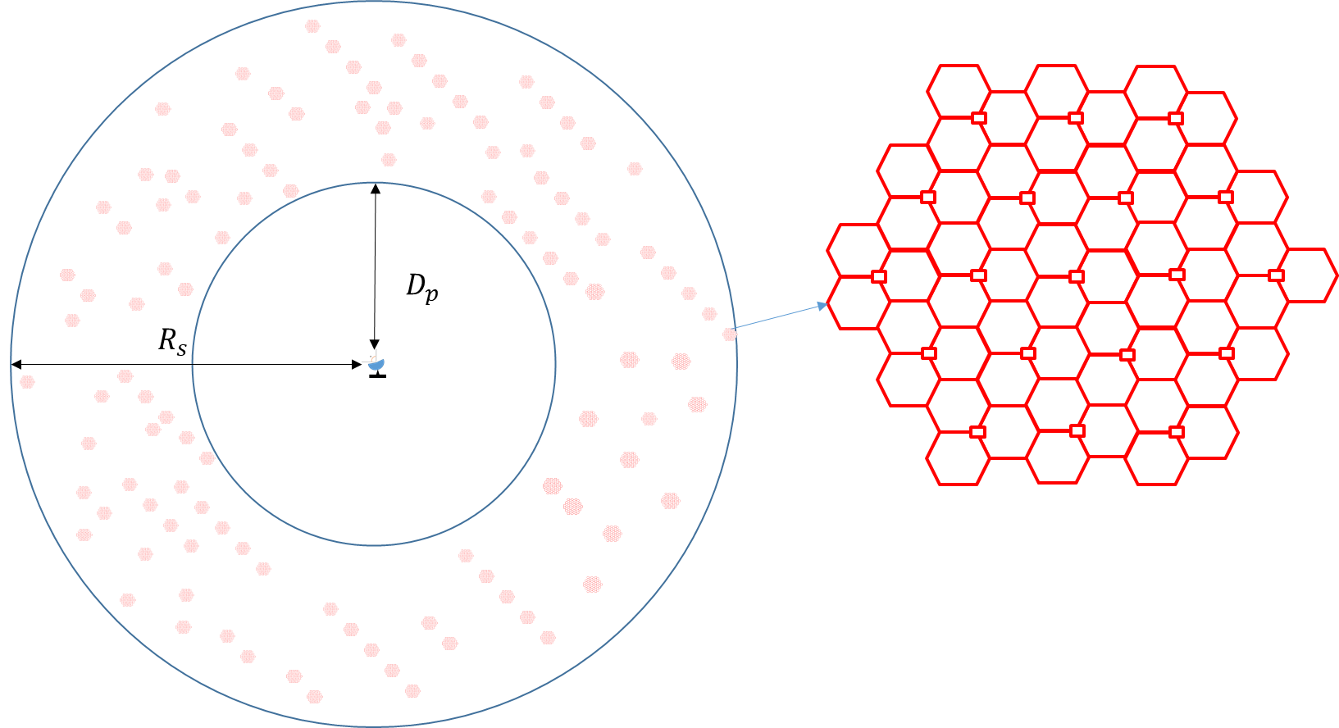
Step 2 – Calculate cluster number in the simulation area
$Cluster number of urban = \frac{cell number of urban, N_{BS,u}}{site num×cell num per site}$
$$N_{BS,u}=D*A= {(ρ}_{u} R_{a,u} R_{b}) A$$
Where the subscript “u” refers to urban and suburban values, and
$D$ = density of simultaneously transmitting BS cells in km^{–2}
$A$ = simulation area in km²
$ρ$ = BS cell deployment density in km^{–2}
$R_{b}$ = ratio (<1) of built-up areas to total area of region under study
$R_{a}$ = ratio (<1) coverage areas to areas of cities/built-up areas/districts.
Step 3 – Model IMT BSs, as well as user equipment in each sector of each BS for the purpose of modelling BS beamforming.
– According to the ITU-R terminology, an IMT BS means 1 sector in a 3-sector cell (see Figure 2).
– Each IMT BS in a cluster is given a random horizontal orientation based
on a uniform distribution (0 to 360°). This is because the orientation of BSs
is a function of local coverage planning, and is independent of the orientation
of the RAS station.
– Each IMT BS in a cluster forms beams towards UEs which are modelled randomly located within the BS’s coverage area with a uniform distribution.
Figure 2
IMT BS illustration according to the ITU-R terminology
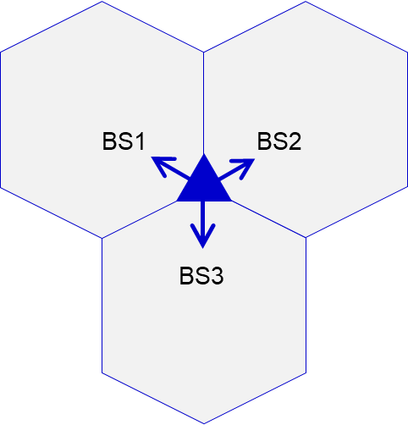 | 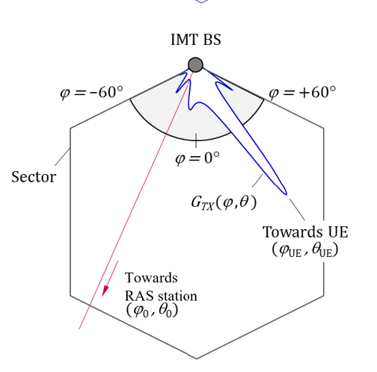
Step 4 – Calculate the interference from each IMT BS in the simulation area (see illustration of different angles on Figure 2 (right)):
$I_{n}=\frac{G_{Tx}(θ_{0},φ_{0 }; θ_{UE},φ_{UE}){ G}_{Rx}\left(ψ_{0}\right)}{L_{clut}\left(θ_{0}\right) L_{prop} L_{pol}} {PSD}_{TX}=G_{n} {PSD}_{TX} \text{ (mW/MHz)}$
where:
$I_{n}$ Single entry interference power from the n^{th} BS in mW/MHz
${PSD}_{TX}$ Total radiated power (TRP) spectral density of the BS in mW/MHz
$θ_{0},φ_{0 }$ Elevation and azimuth angles between RAS station and BS
$θ_{UE},φ_{UE}$ Elevation and azimuth angles of UE when viewed from the BS
$G_{Tx}(θ_{0},φ_{0 })$ Antenna gain of the BS in the direction of the RAS station
$L_{clut}(θ_{0})$ Clutter loss from the BS to RAS station
$L_{prop}$ Propagation loss from the BS to the RAS station
$L_{pol}$ Polarization loss
$ψ_{0}$ Angle of the BS with respect to the RAS station receiver’s boresight
$G_{Rx}(ψ_{0})$ RAS station receiver antenna gain in the direction of the BS.
Step 5 – Calculate the statistical distribution of the aggregate interference I from IMT Base Stations
experienced at the RAS station:
$I=F_{TDD} \sum_{n=1}^{N_{BS}}{I_{n}}$
where:
N_{BS} Total number of IMT base stations in the simulation area
F_{TDD} IMT BS TDD activity factor of 75%.
This aggregate interference is compared with target threshold level of interference for the protection of the RAS receiver and then derive the coordination distance.
Number of IMT Urban BS at 6 GHz considered in the study
Note: According to ITU-R terminology “1 BS” = 1 sector in 3-sector cell.
According to the methodology for calculating the number of BSs in a relatively large area as agreed by WP5D in Annex 4.4 to Document 5D/716, the number of IMT BSs per 100 MHz channel in the 6 GHz band can be written as
$N_{BS,u}=\left(ρ_{u}R_{a,u}R_{b}\right)A=DA$
where:
$D$ Density of simultaneously transmitting BS cells in km^{–2}
$A$ Area of interest in km² (i.e., larger than 200 000 km²)
$ρ$ Base station deployment density in km^{–2}
$R_{b}$ Ratio of built areas to total area of region in study
$R_{a}$ Ratio of coverage areas to areas of cities/built areas/districts
and “u” refer to urban values.
The ring area size of 360 000 km² is simulated.
Table 1
The values of $R_{a}$ and $R_{b}$ used in this document
 | Macro
$$R_{a},u$$ | 10% Urban (area > 200 000 km²)
$$R_{b}$$ | 2% (200 000-1 000 000 km²)
IMT parameters
Table 2 below summarizes IMT system parameters for urban IMT BS used in this study, which align with those in Section 3.
Table 2
IMT parameters used in this coexistence study
Parameter | Parameter value
Network topology | Aggregate case: clusters of IMT networks (57 BSs) are generated within the ring area uniformly
coordination distances | Considered from centre IMT network
Network loading factor | 20% ^{(Note 1)}
Polarization loss | 3 dB ^{(Note 2)}
IMT BS antenna pattern | 8 × 16 × 2 Array elements (H+V)  Beamwidth H/V = 90°/90°  G_{elem} = 5.5 dBi  30 dB f/b ratio  Spacing H/V = 0.5/0.5
IMT Tx power | 26 dBm/MHz
IMT BS height | 18 m (urban)
Number of UE per BS | 3 UEs per BS (uniform distribution)
Note 1: Network loading factor was assumed as 20% in the ring area larger than 50 km².
Note 2: The IMT base station antenna is the ±45° cross-polar, but polarization of a signal received by RAS station antenna can be different, and it would not fully match with that of IMT antenna with high probability, so a polarization loss of $L_{pol}$ = 3 dB was implied.

RAS parameters and protection criteria
Table 3 below summarizes RAS parameters and protection criterion used in this study, which align with those in Section 2.
Table 3
RAS parameters used in this study
 | Parameter considered in the study
Antenna Pattern | an isotropic antenna with a gain of 0 dBi
Antenna height | 50 m
Location | 51°N,16° E
RAS protection criteria | −218.1 dB(W/50 kHz) not exceeded by 2% of time

Propagation modelling
The analysis in this document is based on Recommendation ITU-R P.2001, and 50% time percentage is assumed. According to Recommendation ITU-R P.2001, Tpc (time percentage) for the following sub-models are statistically-independent and randomly-generated in the range 0-100%. The path loss with 50% time percentage matches the path loss median value if we use a random time percentage uniformly distributed within 0 – 100% and randomized at each simulated event. So, 50% time percentage for the Recommendation ITU-R P.2001 is an accurate assumption for statistical simulations considering long-term interference.
Propagation model | Recommendation ITU-R P. 2001-4 (longitude 16 degrees; latitude 51 degrees); time percentage: 50%
Figure 3
Propagation model
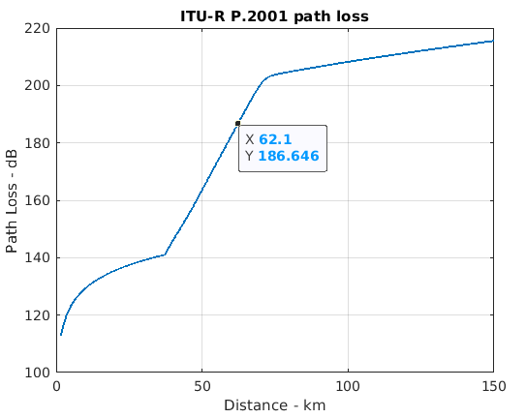
This study uses Recommendation ITU-R P.2108-1 Section 3.2 clutter loss model for terrestrial paths in this analysis.
In order to define propagation conditions, line-of-sight (LOS) or non-line-of-sight (NLOS) concept is used in this paper in order to decide whether clutter loss to be applied or not in Urban scenario. There is a number of LoS/NLoS models in ITU, 3GPP, e.g., Report ITU-R M.2412, 3GPP TR38.901 and WINNER2, demonstrating that for transmitter and receiver heights up to 20 m, there is a very high probability of NLoS condition at distances beyond 1.5 km.
With considerations above clutter loss model is applied to all IMT BSs in this study.
Table 4
Propagation modelling summary
Clutter loss model | Section 3.2 of Recommendation ITU-R P.2108-1
Clutter loss model | 0~100% uniform random value for percentage of locations in Recommendation  ITU-R P. 2108-1
Clutter loss model | Apply clutter loss model of the entire location distribution for all IMT urban BSs
Clutter loss model | No clutter model applied for RAS

Results from sharing studies
The aggregated interference level from the IMT urban Macro BSs is calculated using the parameters and models described in the previous sections of the document, the corresponding CDF curves are shown in Figure 4 below.
Figure 4
CDF curve for in-band scenario
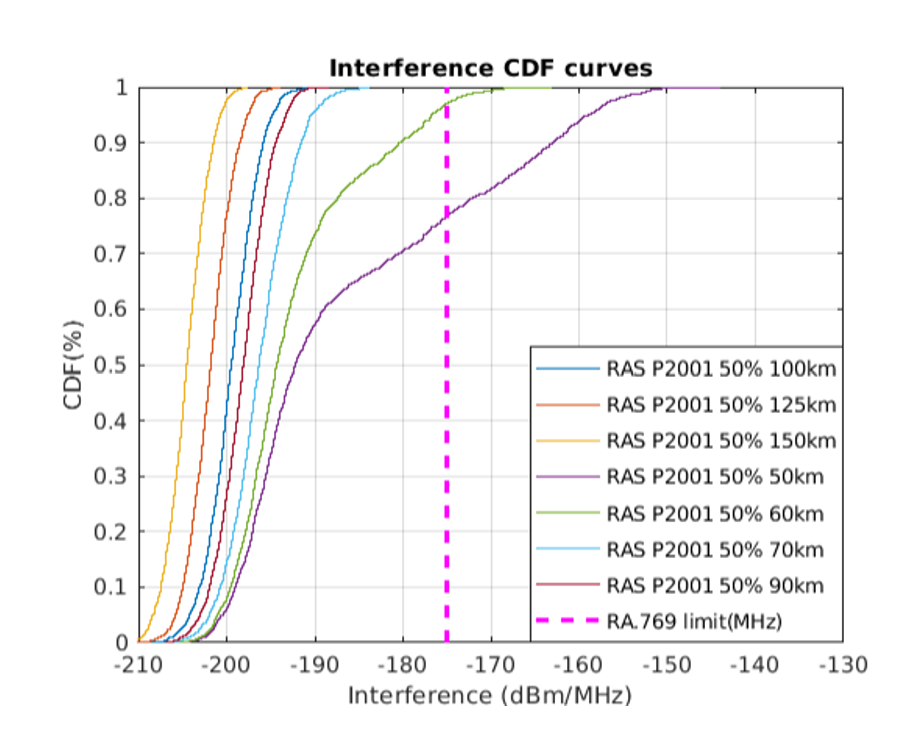
The minimum coordination distance required to ensure coexistence between RAS spectral line measurements and urban IMT macro base stations (in-band scenario) is obtained by comparing the interference levels at the RAS station receiver for the different coordination distances with the RAS protection criteria (–218.1 dB(W/50kHz) which is equivalent to –175.1 dBm/MHz, at 98th percentile of CDF curve for the protection of the RAS receiver).
Therefore, based on this analysis the minimum coordination distance required to ensure protection for the RAS stations from the aggregated interference from the surrounding IMT urban macro cellular network is 62 km.

Annex 2
Mathematical tools

C Mathematical tools

C.1 Calculating effective transmitted IMT power towards RAS stations
This Annex contains procedures and formulae which can be used to determine the (aggregate) received power from an IMT BS and/or UE, or from a full network. It is assumed that the BS locations are known, while the position of UE devices is quasi-random. For typical deployment densities in an IMT network and for information on how BS locations can be derived (if not yet known), see Annex C.3.

C.1.1 Introduction
Every BS can serve up to a given number of UE devices per frequency channel, which will use TDD, i.e., the up- and downlink communication occurs in time slots, which cannot be shared by different user devices. This also means that for a network simulation one needs to average the transmitted power from all devices over a sufficiently large period. To increase the link budget, the BS will dynamically steer its AAS beam towards each of the UE devices within the associated time slot. This also must be considered in a simulation by averaging over the effective antenna gains in time. Likewise, the UE may use AAS beamforming to improve the link budget. As the UE antenna frames can be arbitrarily rotated, the UE beams are also highly dynamic. It is usually assumed, however, that the angular distance between the UE antenna boresight and the actual direction to the host BS is, at most, 60° (otherwise, the UE antenna gain would be too low and the UE device would try to establish a connection to a different BS).
In the following, $\left(u, v, h\right)$ will represent a Cartesian coordinate frame around the RAS station, with $u$ measured to the East, $v$ measured to the North, and $h$ being the height above mean sea level (amsl). Thus, ${\left(u, v, h\right)}_{BS}$ and ${\left(u, v, h\right)}_{UE}$ are the positions of each individual IMT antenna. It is noted that Earth’s curvature must be considered for radio wave propagation. This will be accounted for in a subsequent step. The $\left(u, v, h\right)$ frame can be thought of as a local flat projection of the simulation area, such as UTM or ETRS89. Each BS antenna sector will have a certain bearing (azimuthal direction), $α_{BS}$.

C.1.2 Sampling UE positions in a BS sector
The UEs, which are linked to a certain BS, are not uniformly distributed. It is assumed that each BS serves a given sector covering 120° in azimuth. In this sector, the azimuthal distribution of the UEs is modelled with a normal distribution:
$ρ\left(φ_{UE}\right)=\frac{1}{σ\sqrt{2π}}exp⁡\left(-\frac{{(φ_{UE})}^{2}}{2σ^{2}}\right)$ (A.1)
with $σ=30°$ and $φ_{UE}$ the azimuthal coordination from the BS antenna frame boresight. However, positions shall be restricted to the interval $φ_{UE}=\left[-60°, +60°\right]$, which means that when sampling from the distribution, values outside this interval must be discarded. This accounts for about 5% of the drawn samples.
For the radial distribution of the UEs, i.e., the distance, $d_{UE}$, on the ground between UE and BS, log-normal or Rayleigh distributions are usually employed. The former is recommended for open-space hotspots, while the latter shall be used for other types, i.e., for urban and suburban (outdoor) hotspots. The log-normal distribution is defined as:
$ρ\left(d_{UE}\right)=\frac{1}{d_{UE}σ\sqrt{2π}}exp⁡\left(-\frac{(ln⁡d_{UE}-μ)^{2}}{2σ^{2}}\right)$ (A.2)
with $μ=3.9 m$ and $σ=0.42 m$. The Rayleigh distribution is given by:
$ρ\left(d_{UE}\right)=\frac{d_{UE}}{σ^{2}}exp⁡\left(-\frac{d_{UE}^{2}}{2σ^{2}}\right)$ (A.3)
with $σ=32 m$.
A general method for sampling random numbers adhering to a distribution function is to sample uniformly distributed numbers, $p$, from the interval $p=\left[\left.0, 1\right)\right.$, and feed them into the inverse cumulative distribution function (CDF), which is also called the quantile function (QF). This technique is also known as “Inverse Sampling,” and is a versatile tool for all sorts of random number generators. For continuous probability distributions it is not always possible to derive the QF in analytic form, but for discrete distributions (or approximations of continuous distributions) the strategy explained in Annex A.4 can be employed.
The QF for the normal distribution is:
$φ_{UE}\left(p;μ,σ\right)=μ+σ\sqrt{2}{erf}^{-1}\left(2p-1\right)$ (A.4)
with the inverse error function, ${erf}^{-1}\left(x\right)$. The QF for the log-normal distribution is:
$d_{UE}\left(p;μ,σ\right)=exp⁡\left(μ+\sqrt{2σ^{2}}{erf}^{-1}\left(2p-1\right)\right)$ (A.5)
likewise, the QF for the Rayleigh distribution is given by:
$d_{UE}\left(p;σ\right)=σ\sqrt{-2ln⁡\left(1-p\right)}$ (A.6)
However, numerical libraries for most programming languages or math algebra software provide functionality to sample random values from these distributions, and it is usually recommended to use this for performance reasons.
After sampling the UE positions relative to the BS sector, the position in the global frame is given by:
$$u_{UE}=u_{BS}+d_{UE}cos⁡\left(α_{BS}+φ_{UE}\right)$$  $$v_{UE}=v_{BS}+d_{UE}sin⁡\left(α_{BS}+φ_{UE}\right)$$  $$h_{UE}=h_{ground}\left(u_{UE},v_{UE}\right)+1.5 m$$ | (A.7)
where $h_{ground}\left(u_{UE},v_{UE}\right)$ is the height of the terrain (amsl).

C.2 Beamforming, geometrical calculations, and effective antenna gain
It was already discussed that both BS and UE AAS will be used to actively steer the beam towards the (currently active) counterpart. As the antenna frames are, in general, rotated with respect to the global coordinate frame, it is necessary to compute the beam positions in the antenna frame for each time step and device in order to derive the effective antenna gain in the beam direction and – equally important – the side-lobe gain towards the RAS station receiver. It is noted that the AAS gain pattern is highly dependent on the beam pointing.
Before the equations for this geometrical problem are presented, a few tools are introduced. The calculations can be performed very conveniently and efficiently using 3D linear algebra; in particular, employing rotation matrices. On the other hand, antenna gain formulae are often expressed in terms of spherical angles (i.e., azimuth and elevation). Hence, conversion between the Cartesian description and the spherical coordinate systems is necessary. Furthermore, as the antenna gain calculations are most easily done in the antenna pattern frames, a change of the basis frames is required, which is also discussed below.

C.2.1 Spherical coordinates
A cartesian vector $\left(x, y, z\right)$ can be converted to spherical coordinates $\left(r, ϑ, φ\right)$ via:
$$r=\sqrt{x^{2}+y^{2}+z^{2}}$$  $$ϑ=\frac{π}{2}-arccos⁡\left(\frac{z}{r}\right)$$  $$φ=arctan⁡\left(\frac{y}{x}\right)$$ | (A.8)
where $r$ is the distance of a point to the coordinate center, $ϑ$ is the elevation (not zenith distance!) above the $x$-$y$ plane, and $φ$ is the angle between the projection of the vector $\left(x, y, z\right)$ in the $x$-$y$ plane and the $x$ axis. It is noted that in most computer software, the $arctan2⁡\left(y, x\right)$ function should be used to get the correct quadrant of the result. Below, the spherical coordinates $\left(ϑ, φ\right)$, elevation and azimuth, will, for example, be required for determination of antenna gain values, as many ITU-R models work with spherical angles (and not with cartesian vectors). In this framework, the antenna normal points towards the (positive) $x$-axis, while $y$ is the horizontal and $z$ the vertical axis.
The inverse conversion formulae are:
$$x=rcos⁡ϑcos⁡φ$$  $$y=rcos⁡ϑsin⁡φ$$  $$z=rsin⁡ϑ$$ | (A.9)
For some applications, it can also be useful to calculate the true angular distance, $σ$, between two positions on a sphere:
$σ\left(φ_{1},ϑ_{1},φ_{2},ϑ_{2}\right)=arccos⁡\left(sin⁡ϑ_{1}sin⁡ϑ_{2}+cos⁡ϑ_{1}cos⁡ϑ_{2}cos⁡\left(φ_{2}-φ_{1}\right)\right)$ (A.10)
or the great circle bearing, $α$, under which Position 2 would appear as seen from Position 1:
$α\left(φ_{1},ϑ_{1},φ_{2},ϑ_{2}\right)=arctan⁡\left(\frac{cos⁡ϑ_{2}sin⁡(φ_{2}-φ_{1})}{cos⁡ϑ_{1}sin⁡ϑ_{2}-sin⁡ϑ_{1}cos⁡ϑ_{2}cos⁡(φ_{2}-φ_{1})}\right)$ (A.11)

C.2.2 Rotation matrices
All rotations in 3D cartesian space can be expressed as a 3×3 orthonormal matrix. It is $R^{T}R=1$, which means $R^{T}=R^{-1}$. These can be conveniently constructed from successive applications of up to three elementary rotations:
$$R_{x}\left(α\right)=\left(\begin{matrix}1 & 0 & 0 \\ 0 & \cos{α} & -\sin{α} \\ 0 & \sin{α} & \cos{α}\end{matrix}\right)$$  $$R_{y}\left(α\right)=\left(\begin{matrix}\cos{α} & 0 & \sin{α} \\ 0 & 1 & 0 \\ -\sin{α} & 0 & \cos{α}\end{matrix}\right)$$  $$R_{z}\left(α\right)=\left(\begin{matrix}cos⁡α & -sin⁡α & 0 \\ sin⁡α & cos⁡α & 0 \\ 0 & 0 & 1\end{matrix}\right)$$ | (A.12)
which rotate any vector around the $x$, $y$, or $z$ axis with a rotation angle $α$ (in a mathematically positive sense). There are many different possibilities as to how this can be done which are beyond the scope of this Report. To name just two possibilities, one could use each of the three elementary rotations, e.g., ${R=R}_{z}\left(γ\right)R_{y}\left(β\right)R_{x}\left(α\right)$, or just two of them, e.g., ${R=R}_{z}\left(γ\right)R_{x}\left(β\right)R_{z}\left(α\right)$. Some of the many possible combinations are known as (classic) Euler angle representations.
An alternative method is to express a rotation via its (normalized) rotation axis, $\hat{r}=\vec{r}/\left|\vec{r}\right|$, and angle, $α$:
$R=E+sin⁡\left(α\right)W+2sin⁡\left(α/2\right)W^{2}$ (A.13)
where:
$E=\left(\begin{matrix}1 & 0 & 0 \\ 0 & 1 & 0 \\ 0 & 0 & 1\end{matrix}\right), W=\left(\begin{matrix}0 & -{\hat{r}}_{z} & {\hat{r}}_{y} \\ {\hat{r}}_{z} & 0 & -{\hat{r}}_{x} \\ -{\hat{r}}_{y} & {\hat{r}}_{x} & 0\end{matrix}\right)$ (A.14)

C.2.3 Basis systems and basis change
The elements (values) of vectors and matrices are tied to the choice of a basis frame. When a basis frame is changed, e.g., when one converts between a global frame (such as the simulation box) and a local frame (rotated antenna frame), the new elements need to be calculated. As an example, consider a vector $\vec{x}=\left(x,y,z\right)$ in a given frame $A$. This vector can be rotated with a given rotation matrix $R$:
${\vec{x}}^{'}=R\vec{x}\left(3.15\right)$
The resulting elements ${\vec{x}}^{'}=\left(x^{'},y^{'},z^{'}\right)$, however, will still be in frame $A$. On the other hand, it is also possible to rotate the frame (with the same rotation matrix), resulting in frame $B$, and calculate the elements of the same vector $\vec{x}$ in the rotated frame:
${\vec{x}}^{B}=\left(\begin{aligned}\vec{x}⋅{\hat{e}}_{x_{B}} \\ \vec{x}⋅{\hat{e}}_{y_{B}} \\ \vec{x}⋅{\hat{e}}_{z_{B}}\end{aligned}\right)=\left(\begin{aligned}\vec{x}⋅R{\hat{e}}_{x} \\ \vec{x}⋅R{\hat{e}}_{y} \\ \vec{x}⋅R{\hat{e}}_{z}\end{aligned}\right)=R^{T}{\vec{x}}^{A}$ (A.16)
Likewise, because $R^{T}=R^{-1},$it is also true that ${\vec{x}}^{A}=R{\vec{x}}^{B}$. It is also possible (and necessary) to change the elements of a matrix, $M$, if a basis change is performed:
$M^{B}=R^{T}M^{A}R$ (A.17)
as can be seen when applying the matrix to a test vector (in frame $B$):
$M^{B}{\vec{x}}^{B}=R^{T}M^{A}R{\vec{x}}^{B}=R^{T}M^{A}{\vec{x}}^{A}$ (A.18)
where in the first step, the vector is experiencing a basis change from $B$ to $A$, then the matrix $M$ (expressed in basis $A$) is applied, and finally the result is expressed in basis $B$ by multiplication with $R^{T}$. In the following, this technique will make it possible to easily convert (and concatenate) antenna frame rotations in a very simple manner.

C.2.4 Beam pointing in rotated frames
Every BS antenna is usually subject to an azimuthal rotation (bearing), $α_{BS}$, and potentially a mechanical down-tilt, $ε_{tilt}$. This can be represented as a concatenation of two elementary rotations:
$R_{BS}=R_{z}\left(α_{BS}\right)R_{y}\left(ε_{tilt}\right)$ (A.19)
It is noted that this rotation must not be applied to the global $\left(u, v, h\right)$ coordinate of the BS, but to a device-local frame ${\left(x,y,z\right)}^{nrl}$. Before any rotation is applied, this non-rotated local (nrl) frame is aligned with the global $(u, v, h)$ frame, but the origin is shifted to the antenna location. Likewise, we define the rotated local (rl) frame, ${\left(x^{'},y^{'},z^{'}\right)}^{rl}$, which stems from applying any rotation on the nrl frame about the origin of the nrl frame, i.e., the nrl and rl frames have an identical origin. The rl frame represents the actual antenna frames for quasi-randomly oriented antennas, while the nr frame is merely needed to convert device and antenna positions from rl to global $\left(u, v, h\right)$ coordinates. For brevity, we will use the notation $\left(x,y,z\right)$ and $\left(x^{'},y^{'},z^{'}\right)$ hereafter for the nrl and rl frames, respectively.
For the UE, an arbitrary (random) 3D rotation $R_{UE}$ acts on the device-local nrl frame. However, there exists the constraint that the maximum coordination between the UE antenna boresight and the pointing vector to the host BS is less than 60° (see above). There are three options to take this into account, with the first being the simplest, but the last being computationally more efficient and elegant.
Option 1: Create random rotation and discard samples
Sample three rotation angles from uniform distributions such that $α_{i}∈\left[-180°, +180°\right]$, and compute:
$R_{UE}=R_{z}\left(α_{3}\right)R_{x}\left(α_{2}\right)R_{z}\left(α_{1}\right)$ (A.20)
It is noted that other combinations of elementary rotations would also work and that the sphere is covered twice, i.e., for one angle $α_{2}$ it would suffice to use only angles from $\left[-90°, +90°\right]$. This rotation could now be applied to any vector of length 1, such as ${\hat{e}}_{x}$, to create a random position on the unit sphere, which shall represent the normal vector of the UE antenna frame. Using Eq. (A.8) the corresponding azimuth and elevation angles $\left(φ_{ant, UE}^{nrl},ϑ_{ant,UE}^{nrl}\right)$ can be calculated.
Now, determine the vector between the UE and host BS:
${\vec{n}}_{UE}={\left(\begin{aligned}x \\ y \\ z\end{aligned}\right)}_{BS←UE}={\left(\begin{aligned}u \\ v \\ h\end{aligned}\right)}_{BS}-{\left(\begin{aligned}u \\ v \\ h\end{aligned}\right)}_{UE}$ (A.21)
where the meaning of the subscript “$BS←UE$” is: “the direction to the BS, as seen from the UE.” (The elements of the vector ${\vec{n}}_{UE}$ are thus again defined in the device-local nrl frame). After normalization:
${\hat{n}}_{UE}={\vec{n}}_{UE}/\left|{\vec{n}}_{UE}\right|$ (A.22)
this can again be converted to azimuth and elevation angles $\left(φ_{BS←UE},ϑ_{BS←UE}\right)$. Now the cases where the angular coordination between the UE antenna normal and the direction to the BS (as seen from the UE) are larger than 60° can be discarded, i.e., keep only samples with:
$σ\left(φ_{ant, UE},ϑ_{ant,UE},φ_{BS←UE},ϑ_{BS←UE}\right)≤60°$ (A.23)
This method is obviously somewhat inefficient, as more random samples need to be generated than are necessary. Furthermore, more complicated constraints may be more difficult to implement. It would also be possible to use a different procedure to create a unit vector on the sphere.
Option 2: Construct rotation matrix in world coordinates
Again, a rotation matrix will be constructed from three (non-elementary) rotations:
$R=R_{3}\left(α_{3}\right)R_{2}\left(α_{2}\right)R_{1}\left(α_{1}\right)$ (A.24)
Start from the hypothetical situation where the UE antenna normal was pointing to the host BS already, i.e., take ${\hat{n}}_{UE}$ as defined in the method above. The first rotation matrix, $R_{1}\left(α_{1}\right)$, shall perform a rotation about the UE-BS axis $\left({\vec{a}}_{1}∶={\hat{n}}_{UE}\right)$ with angle $α_{1}∈\left[-180°, +180°\right]$. It can be computed using the axis-angle approach, see Eq. (A.13). This rotation will leave the antenna normal vector untouched. Next, a rotation with a maximum angle of 60$°$ around any axis perpendicular to the UE-BS axis is applied. Without loss of generality, the axis lying in the $\left(x,y\right)$ plane is used, as determined by:
${\vec{a}}_{2}={\vec{a}}_{1}×{\hat{e}}_{z}=\left(a_{1,y},-a_{1,x},0\right)=\left(v_{BS}-v_{UE},u_{UE}-u_{BS},0\right)$ (A.25)
Again, before equation (A.13) can be used, the (rotation) axis vector must be normalised, i.e., use ${\hat{a}}_{2}={\vec{a}}_{2}/\left|{\vec{a}}_{2}\right|$ and rotate with $α_{2}$ randomly sampled from $\left[0°, +60°\right]$. Finally, rotate again about ${\vec{a}}_{1}$ with $α_{3}$ randomly sampled from $\left[-180°, +180°\right]$. Unlike in the first step, this time the UE-BS vector is not invariant under the rotation because the second rotation has tilted the coordinate frame away from the UE-BS axis.
Option 3: Construct rotation matrix in local frame and apply basis change
The method described in the previous section can also be constructed from two concatenated rotations. First, one can define a rotation that converts from the nrl frame to an initial frame (“init”), in which the antenna normal vector points to the host BS. Afterwards, the random UE rotation can easily be constructed using elementary rotation matrices only:
${\tilde{R}}_{UE}=R_{x}\left(α_{3}\right)R_{y}\left(α_{2}\right)R_{x}\left(α_{1}\right)$ (A.26)
with $α_{1,3}∈\left[-180°, +180°\right]$ and $α_{2}∈\left[0°, +60°\right]$. The initial rotation is given by:
$R_{UE,nrl→init}=R_{z}\left(φ_{UE-BS}\right)R_{y}\left(-ϑ_{UE-BS}\right)$ (A.27)
where ${\left(φ, ϑ\right)}_{UE-BS}$ is the spherical coordinate of the vector ${\vec{n}}_{UE}$ in the nrl frame. To obtain the final UE rotation matrix (expressed in the nrl frame), a simple basis change is required:
$R_{UE}=R_{UE,nrl→init}{\tilde{R}}_{UE}R_{UE,nrl→init}^{T}$ (A.28)

C.2.5 Determination of effective antenna gains
Several specific antenna gain values are necessary for aggregation simulations. For the UE power control algorithm, the link budget between UE and its host BS needs to be computed. For this, not only the path propagation according to 3GPP TR 38.901 (section 7.4.1) is considered, but also the antenna gains of the UE antenna (in direction of the host BS) and the gain of the BS antenna in the direction of the UE. In both cases, it is assumed that the beams are formed towards the communication partner, while the antennas are, in general, not pointing towards the other device. With the frame rotation matrices derived in the previous sections, we find for the UE position expressed in the BS frame (rl):
${\left(\begin{aligned}x^{'} \\ y^{'} \\ z^{'}\end{aligned}\right)}_{beam,UE←BS}=R_{BS}^{T}\left({-\vec{n}}_{UE}\right)$ (A.29)
where the meaning of the subscript “$UE←BS$” is: “the direction to the UE, as seen from the BS.” Likewise, the BS position expressed in the UE frame (rl) is:
${\left(\begin{aligned}x^{'} \\ y^{'} \\ z^{'}\end{aligned}\right)}_{beam,BS←UE}=R_{UE}^{T} {\vec{n}}_{UE}={\tilde{R}}_{UE}^{T}\left(\begin{aligned}1 \\ 0 \\ 0\end{aligned}\right)$ (A.30)
in which the last equality is a trivial consequence of the choice of frames in Option 3 above.
The effective antenna gains can be calculated by converting the resulting cartesian vectors, which are expressed now in the rl antenna frames, to spherical angles $\left({φ'}_{beam}, {ϑ'}_{beam}\right)$ and feeding these into the AAS pattern of Rec. ITU-R M.2101-0 Table 4 for both the actual angles, $\left(φ,θ\right)=\left({φ'}_{beam}, {90°-ϑ'}_{beam}\right),$ and the beam position, $\left(φ_{i,escan}, θ_{i,tilt}\right)=({φ'}_{beam}, {-ϑ'}_{beam})$.
The same must be done for the effective gain of the BS and UE antenna patterns in the direction of the RAS station. As both the terrain heights and the curvature of the Earth do play a role, in a first step, the bearing angles towards the RAS station as well as the local horizon elevation angles must be determined. These are usually calculated as a by-product in the path propagation (pp) calculations as proposed in Rec. ITU-R P.452-17, for example. We denote the direction to the RAS station as ${\left(φ,θ\right)}_{pp}$ (in nrl frame).
To calculate the gain, this position needs to be expressed in the antenna frames, i.e.:
$${\left(\begin{aligned}x^{'} \\ y^{'} \\ z^{'}\end{aligned}\right)}_{Rx←BS}=R_{BS}^{T}{\vec{x}}_{pp,BS}$$  $${\left(\begin{aligned}x^{'} \\ y^{'} \\ z^{'}\end{aligned}\right)}_{Rx←UE}=R_{UE}^{T}{\vec{x}}_{pp,UE}$$ | (A.31)
where ${\vec{x}}_{pp,BS}$ and ${\vec{x}}_{pp,UE}$ are the cartesian vectors associated with $\left({1, φ}_{pp},θ_{pp}\right)$ at the BS and UE positions. As before, the gains can now be determined using Rec. ITU-R M.2101-0.
Figure B1
Coordinate frames of BS and UE antennas
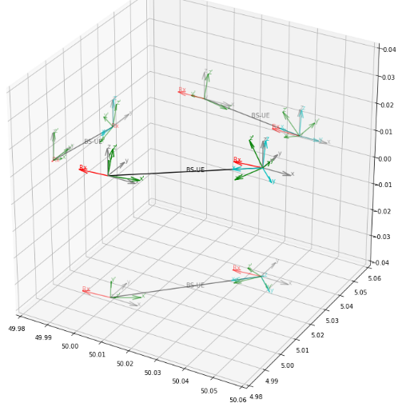
The various coordinate frames are visualized in Figure B1. The axes show the global $\left(u, v, h\right)$ coordinates, with the RAS station located at the origin of this frame. There is one BS at position $\left(50 km, 5 km, 6 m\right)$ with a bearing angle of $α_{BS}=30°$ and a down-tilt of $ε_{tilt}=10°$. A UE device is placed at a distance of $d_{UE}=50 m$ with an azimuthal angle of $φ_{UE}=15°$ into the BS antenna footprint. Thus, the global position of the UE is ${\left(u, v, h\right)}_{UE}=\left(50.0354 km, 5.0354 km, 1.5 m\right)$. All terrain heights are assumed to be zero. For the UE rotation, the angles $\left({α_{1}, α}_{2},α_{3}\right)=\left(10°, 20°, 30°\right)$ are used. In Fig. B1, the grey arrows show the nrl frames at the BS and UE positions, respectively. The green arrows indicate the antenna (rl) frames. For illustration, the init frame is also displayed, in which the UE antenna normal is pointing to the BS. Red arrows mark the path propagation vector towards the RAS receiving station.
In order to apply Recommendation ITU-R P.452-17, the BS and UE positions must be known in WGS84 longitudes and latitudes, $\left(l, b\right)$. For the example in Figure B1, it is assumed that the RAS station is at ${\left(l, b\right)}_{Rx}=\left(7°, 50°\right)$. As previously mentioned, one can utilise a local flat projection such as UTM to convert between $\left(u, v, h\right)$ and WGS84 coordinates. Then, ${\left(l, b\right)}_{BS}=\left(7.6962°, 50.0549°\right)$ and ${\left(l, b\right)}_{UE}=\left(7.6967°, 50.0552°\right)$. Recommendation ITU-R P.452 predicts ${\left(φ_{pp},θ_{pp}\right)}_{Rx←BS}=\left(-173.290°, -0.069°\right)$ and ${\left(φ_{pp},θ_{pp}\right)}_{Rx←UE}=\left(-173.254°, -0.034°\right)$.
Figure B2
Phased-array antenna gain for BS and positions of the formed beam (black circle) and RAS station (red circle)
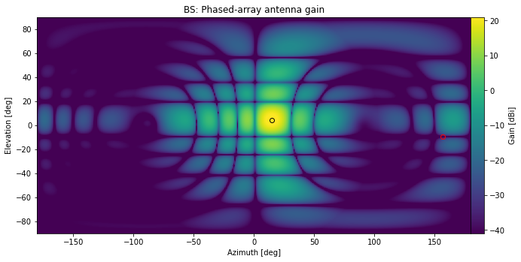
Based on this we find for the UE device position in the BS antenna frame (rl), ${\left({φ'}_{beam},{θ'}_{beam}\right)}_{UE←BS}=\left(14.986°, 4.518°\right)$, and for the RAS position (or rather the propagation path’s position) ${\left({φ'}_{pp},{θ'}_{pp}\right)}_{Rx←BS}=\left(156.385°, -9.246°\right)$, respectively. The former is marked with a black circle in Figure B2, while the latter is indicated with a red circle.
Figure B3
Phased-array antenna gain for UE and positions of the formed beam (black circle) and RAS station (red circle)
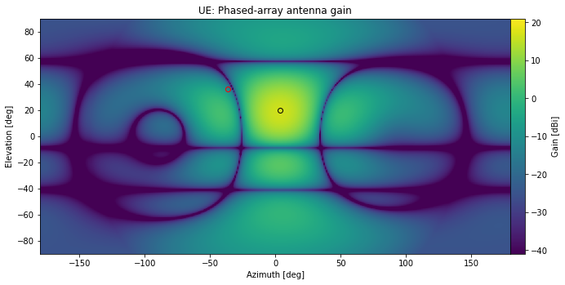
Likewise, the beam (to the BS) and RAS Rx positions in the UE frame (rl) are, ${\left({φ'}_{beam},{θ'}_{beam}\right)}_{BS←UE}=\left(3.616°, 19.683°\right)$ and ${\left({φ'}_{pp},{θ'}_{pp}\right)}_{Rx←UE}=\left(-36.219°, 36.319°\right)$; see Figure B3.

C.3 Sampling BS locations according to land cover types
For generic aggregation studies, one of the first steps in the calculations is to simulate the deployment of BSs and UEs. In Recommendation ITU-R M.2101, several possible IMT network topologies are discussed, such as hexagonal or Manhattan-style (rectangular) grid layouts. However, typical deployment number densities and other technical parameters vary with the target IMT frequency band and technology generation. Such numbers are usually provided by the involved working parties.
For generic simulations, the provided IMT parameters usually include typical device densities for the relevant land-cover type zones, such as urban/suburban or rural areas. However, in most cases, no specifications are made with respect to the spatial distribution functions of devices. This usually has to do with the fact that for small-area simulations a single zone type can be assumed, and within these it makes sense to work with a relatively homogeneous deployment, as proposed in Recommendation ITU-R M.2101. For very large areas, the actual distribution usually has a less significant impact on the (statistical) results. For RAS, however, one can think of setups where the actual “clustering” of urban/suburban zones might play a role. Indeed, RAS stations are often in remote areas, but there could be some smaller towns nearby which would introduce a strong direction dependence with regards to minimum coordination distances.
Technically, some of the IMT studies make a difference between built-up area (i.e., having housings), in which (sub)urban zones are embedded, while in other studies –especially at lower frequencies– IMT BSs could also be deployed anywhere (i.e., also in rural areas) not necessarily associated with housings. In the following, as this Report is about 5G at mm waves, the former scenario will be used. For mm-wave 5G it is furthermore expected that BSs will only be installed in (sub)urban areas. The fraction of the total area that contains housings is usually denoted as $R_{b}$. Within this, only a part of the area is thought to have urban or suburban land cover. This fraction is the so-called $R_{a}$ parameter.
The following recipe could be used to create quite realistic zone maps. It is based on the observation that densely populated areas, such as cities and towns, cover a certain (connected) area. In addition, suburban areas often surround urban cores in a city. Such spatial correlations can be introduced numerically in different ways, but one of the easiest methods is to smooth-down a map consisting of uncorrelated noise samples.
Figure B4
Creating pseudo-land-cover class zones by creating a spatially correlated noise map
and applying thresholds
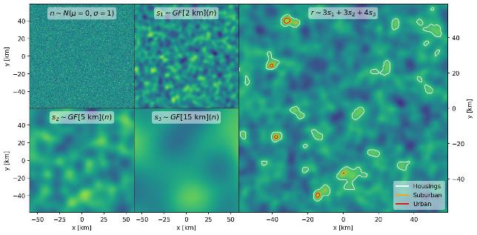
The method is visualized in Figure B4. The individual steps are:
1 Create a map of spatially uncorrelated noise, e.g., by drawing random samples from a normal distribution (independently for each pixel); see top left panel of Figure B4.
2 Apply a spatial filter, such as a Gaussian filter, $GF\left[σ_{m}\right]\left(n\left(x, y\right)\right)$, with various kernel sizes, $σ_{m}$. In the example in the figure, the kernel sizes $σ_{m}=2, 5,$ and $15$ km have been used.
3 Sum the smoothed-down versions of the map. Applying weighting factors is an option and can be used to give certain distance scales more impact. The result of this is shown in the right panel of Figure B4.
4 Apply thresholds based on the percentile levels associated with the required housing ($R_{b}$) and/or area ratios ($R_{a}$). In the example, $R_{b}=5\%$, and $R_{a}^{urban}=7\%$ and $R_{a}^{suburban}=3\%$, respectively, i.e., the lowest threshold—which defines the housing area—is at 95% (${=100\%-R}_{b}$), while the threshold for suburban areas is at 99.5% (${=100\%-R}_{b}(R_{a}^{urban}+R_{a}^{suburban})$) and for urban it is at 99.65% (${=100\%-R}_{b}R_{a}^{urban}$). Obviously, the area marked as “suburban” also includes the “urban” areas, such that the “highest” zone type should be used subsequently for each pixel in the simulation box.
The result can also be displayed in a different style, without contours, as in Figure B5. The next task to be addressed is how to sample BS locations into the simulation box, such that the given number densities and land cover types are respected. For this, again, the “inverse sampling” procedure can be used, which is discussed in Annex B.4. The method also works for n-dimensional data. The 2-D land cover map can be transformed into a number density map by assigning a (fixed) number density to each pixel according to the zone type. This density map can be understood as a discrete two-dimensional probability distribution, if it was normalized. Hence, the inverse sampling is realized by flattening the map (i.e., create a 1-D array consisting of the rows of the map), computing the cumulative sum, and dividing the result by the sum of all densities (or by the last element of the cumulative-sum array). To illustrate this, a toy map has been created with just one of each zone type; see Figure B6. If the pixel grid is relatively coarse, it is furthermore a viable strategy to add some sub-cell random shifts to each location. This helps to keep the computational costs small while not losing much accuracy.
Figure B5
Result of the procedure depicted in Figure B4 with the various zone types highlighted as coloured regions
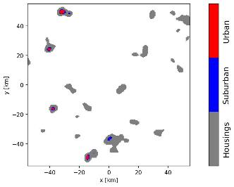
Figure B6
Sampling BSs into different zones. The BS number densities are 10 / km² for suburban
and 30 / km² for urban zones
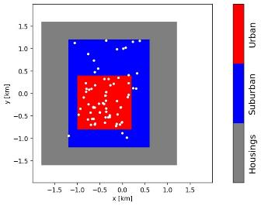

C.4 Inverse sampling
If one needs to sample random numbers adhering to a given probability distribution, the “inverse sampling” technique can be used. Here the discrete version is explained, which works with any discrete probability distribution, $ρ\left(x\right),$ and can also be used to approximate continuous cases. The basic idea is sketched in Figure A7. Mathematically, the inverse CDF, $F^{-1}$, is determined and random numbers from the uniform distribution are fed into it:
$x_{n}\sim F^{-1}\left(y_{n}\right), with y_{n}\sim U\left(0,1\right) and F\left(x\right)=\int_{0}^{x}{ρ\left(x^{'}\right)dx'}.$ (3.32)
For discrete distributions or numerical approximations, the integral is replaced with the sum, in which case $F\left(x\right)$ becomes the cumulative sum of $ρ\left(x\right)$. Taking the inverse is then a search operation in the CDF curve, i.e., finding the piece of the curve having the required $y_{n}$-value, which gives the associated $x_{n}$.
Figure B7
The inverse sampling technique can be used to generate random numbers adhering to a given
target probability distribution by using the inverse CDF (or an approximation of it)
and feeding in uniformly distributed random samples
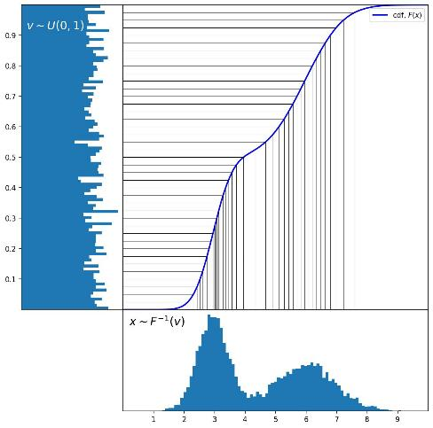

Annex 3
Example studies for generic and site-specific cases

It presents an example for calculating the coordination areas around the RAS station to protect RAS from aggregate interference of IMT with urban deployment using the dynamic Monte Carlo simulation method defined in this report. It also analyzed single-entry interference for site-specific scenario from BS with suburban/rural deployment to RAS station for sensitivity case. It’s noted that IMT base stations in rural areas may not be typical for 6 425-7 125 MHz frequency band, it’s not expected to be deployed contiguously and any such base stations that may exist in small numbers will be isolated installations at specific locations.
IMT-2020 parameters
Parameters of IMT-2020 are provided in Table 1, these parameters were approved by the Working Party (WP) 5D and can be also found in Annex 4.4 to Document 5D/716
Table 1
IMT technical parameters for base stations and user equipment in the band 6 425-7 025 MHz
Parameters | IMT Base station | IMT User equipment
Band parameters
Frequency | 6.65 GHz | 6.65 GHz
Carrier bandwidth | 100 MHz | 100 MHz
Antenna parameters (Rec. ITU-R M.2101-0)
Antenna pattern | Rural¹/suburban  8 × 16 × 2 Array elements (H+V)  Beamwidth H/V = 90°/65°  G_{elem} = 6.4 dBi  30 dB f/b ratio  Spacing H/V = 0.5/0.7  Urban  8 × 16 × 2 Array elements (H+V)  Beamwidth H/V = 90°/90°  G_{elem} = 5.5 dBi  30 dB f/b ratio  Spacing H/V = 0.5/0.5 | −4 dBi (avg. isotropic)  Single-element
Down-Tilt | 6° (Sub/Rural)  10° (Urban) | N/A
Antenna height | 25 m¹ (Rural)  20 m (Suburban)  18 m (Urban) | 1.5 m
Emitted powers
Ptx | 22 dBm per element | 23 dBm
Spectral mask (relative to total conducted power of carrier) | −50.1 dBc/MHz (adjacent) | −30 dBc/MHz (adjacent)
Ohmic losses (included in G_{elem}) | 2 dB | 2 dB
Other losses | N/A | 4 dB (body loss)
Conducted spectral power density  (Total array, without gain) | 26 dBm/MHz (in-band)  −4 dBm/MHz (adjacent) | 3 dBm/MHz (in-band)  −7 dBm/MHz (adjacent)
Power into RAS frequency band (Spectroscopy channel width: 50 kHz) | 13 dBm (in-band)  −17 dBm (adjacent) | −10 dBm (in-band)  −20 dBm (adjacent)
UE power control parameters | N/A | PCMAX = 23 dBm  P0 PUSCH = −95.5 dBm  α = 0.8
Network loading factor | 20% | N/A
TDD activity factor | 75% | 25%
Deployment
Rb (housing ratio) | 2%
Ra (ratio of hotspot area to housing area) | 10%¹ (Rural)  5% (Suburban)  10% (Urban)
Deployment density in hotspot area (number of sectors; 3 sectors per BS position) | 0.006 km⁻² (Rural)  2.4 km⁻² (Suburban)  10 km⁻² (Urban) | 3 UEs per BS sector
Number of indoor devices | N/A | 50%¹ (Rural)  70% (Suburban)  70% (Urban)
Distribution of user equipment (relative to base station)
BS cell radius | 1.2 km¹ (Rural)  0.6 km (Suburban)  0.3 km (Urban)
Angular distribution | Normal(0, 30) (clipped at ± 60°)
¹ Rural parameters were mostly undefined for the IMT band 6 425-7 025 MHz in Document 5D/716 (Annex 4.4) it is also noted that rural deployment is not expected to be common for that band and will be mostly rare isolated installations.

RAS parameters
The study takes into account spectral line observations to take into account the most stringent protection criterion. It should be noted that for VLBI interferometers, protection criterion is less stringent.
Parameter | Value
Frequency range | 6 650-6 675.2 MHz
Channel | 50 kHz
Antenna height | 50 m
Antenna pattern | An isotropic antenna with a gain of 0 dBi
Noise temperature | 10 K
RAS protection criteria | 218.1 dB(W/50kHz) at 98th percentile for the protection of the RAS receiver

The protection criterion for RAS is based on Recommendation ITU-R RA.769, at the same time it should be noted that for this particular band there is actually no protection criterion, so the recommendation is used as the closest available value.
Simulation methodology of aggregate interference
Generic study that estimates aggregate interference employs Monte-Carlo simulation analysis where at each step IMT base stations are generated around the victim receiver as the 19 trisector BS clusters, so total number of sectors per each cluster is 57. In order to calculate the number of clusters, Ra Rb approach should be used.
Based on the methodology developed by WP 5D, the number of IMT BSs per 100 MHz channel in the 6 GHz band can be calculated using the follow equation:
$N_{BS,total}=\left(ρ_{u}R_{a,u}R_{b}\right)A$
where:
$ρu$ Base station deployment density in km²
$R_{a}$ Ratio of coverage areas to areas of cities/built areas/districts
$R_{b}$ Ratio of built areas to total area of region in study
$S_{area}$ Studied area expressed on km².
In this study for Ra 10% value was used and for Rb 2% value was used. Total area size was 360 000 km². The was divided into ring layers, the first layer was the required coordination distance, whereas the second layer was the simulation area where. The circle layer approach is presented in Figure 1.
Figure 1
Methodology of simulation the interference from IMT to RAS
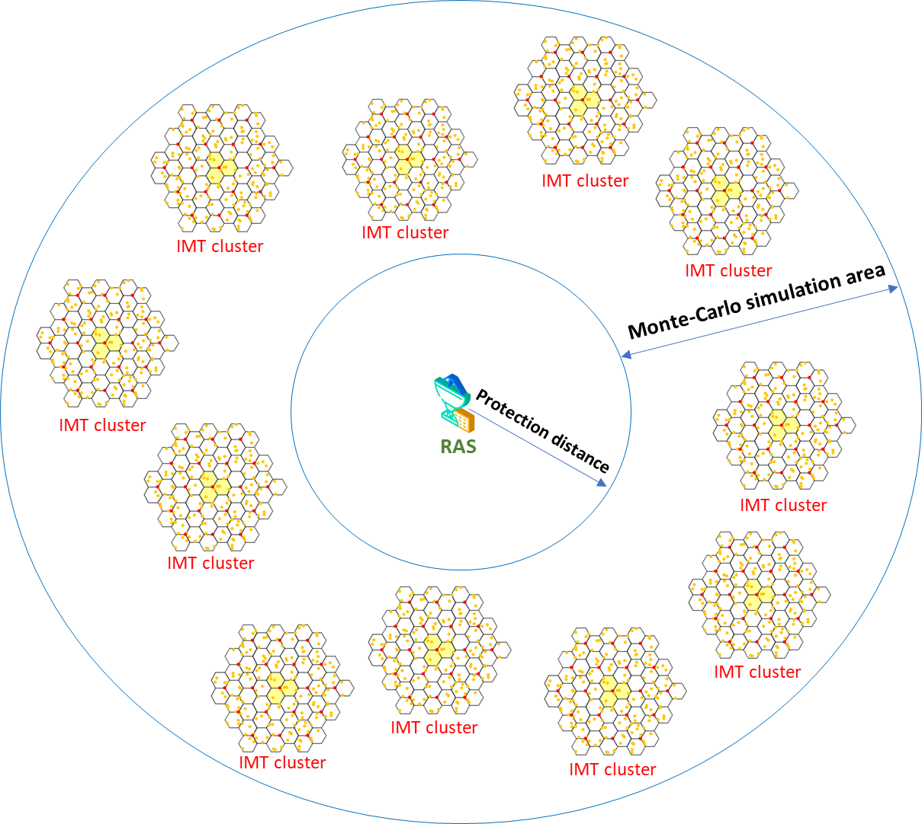
To estimate the number of simultaneously transmitting BS, TDD activity factors and network loading factor should be taken into account. For the wide studying areas network loading factor is 20%, thus total number of simultaneously transmitting IMT clusters can be expressed below:
$N_{clusters}=\frac{\left(ρ_{u}R_{a,u}R_{b}\right){S_{area}A}_{TDD}A_{loading}}{57}$
At each simulation step the antenna of the BS is electronically steered depending on the user’s position, an example of electronic antenna steering based on Recommendation ITU-R P.2101 presented in Figure 2.
Figure 2
Base station antenna array pattern for different beam steering angles
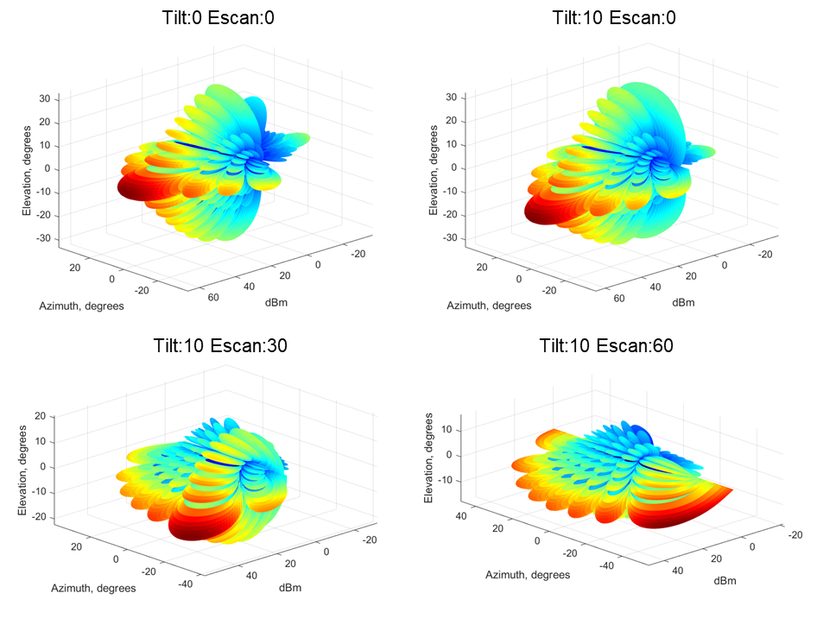
The BS beamforming precoding is used and multiple spatially directive signals are transmitted simultaneously. In simulations, the emission consisted of three directive beams pointing to every user in each sector; the output power of the beam was evenly split to each user as shown in Figure 3 below.
Figure 3
Beam distribution used in simulations and gain pattern of each beam
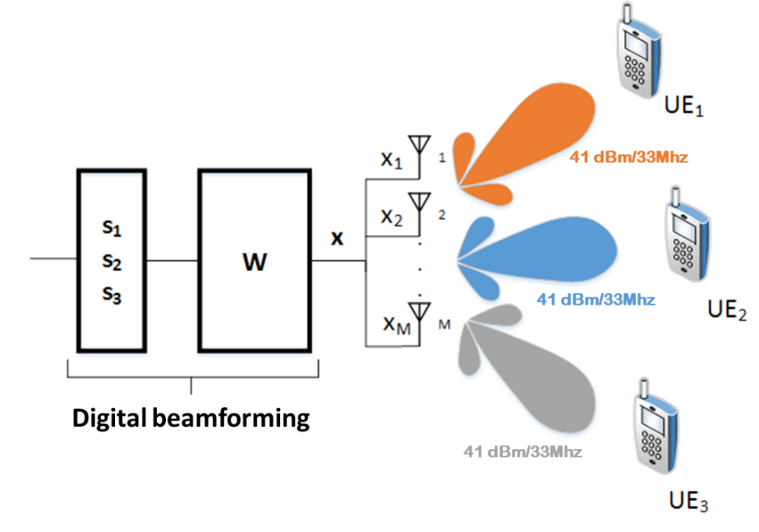
The value 41 dBm/33 MHz was obtained using the following expression:
$P_{33MHz}=22+10\log\left(8 ×16 ×2\right)-10log⁡(3)$
Propagation model
To calculate propagation losses the model based on Recommendation ITU-R P.2001 is used. This Recommendation was among those that were allowed to be used for 6 GHz band by WP 3K/3L. This Recommendation describes a radio-wave propagation method for terrestrial paths. It has a wide range of applicability in frequency, distance, and percentage time. In particular, it predicts both fading and enhancements of signal level. It is thus particularly suitable for Monte-Carlo simulations. For Monte-Carlo simulations random percentage of time for each interfering base station should be used, given that essentially it corresponds the average, 50% value has been used.
For IMT with urban deployment, clutter should be used. The clutter losses can be calculated using the propagation model based on Recommendation ITU-R P.2108. Random percentage of locations is used. Figure 4 provides propagation losses of Recommendation ITU-R P.2001 for 50% of time without clutter (blue curve) and propagation losses taking into account clutter losses (red dots).
The clutter is applied for all transmitting BS given that their height is 18 meters and most of the urban building height is from 20 to 30 meters, therefore the probability that the path between the transmitting BS and RAS station will be covered by clutter is very high. Additionally, it should be noted that most of the WP 5D studies under 1.2 agenda item during the WRC-23 study cycles applied clutter for 100% base stations.
Figure 4
Propagation losses of Recommendation ITU-R P.2001 with 50% percentage of time
with and without clutter losses
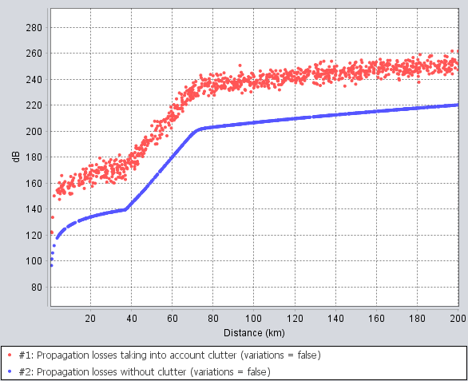
Generic case study
The study employed Monte-Carlo simulation, at each step the location of each use within the cell was randomly distributed according to the uniform distribution. The interference at each step can be calculated using the following expression:
$I=P_{tx}+G_{tx}\left(θ,φ\right)+G_{rx}\left(θ,φ\right)-L_{2001}-L_{clutter}-L_{pol}$
where:
$P_{tx}$ : Output power of the BS in dBW
$G_{tx}(θ,φ)$ : Antenna gain of the BS towards the RAS station in dBi
$G_{rx}(θ,φ)$ : Antenna gain of the RAS towards the BS in dBi
$L_{2001}$: Propagation losses based on Recommendation ITU-R P.2001
$L_{clutter}$ : clutter losses based on Recommendation ITU-R P.2108 in dB
$L_{pol}$ : Polarization difference losses in dB.
Figure 5 shows the simulation example of interference from IMT to RAS in the 6 650-6 675 MHz frequency band using Monte-Carlo approach.
Figure 5
Propagation losses of Recommendation ITU-R P.2001 with 50% percentage of time
with and without clutter losses
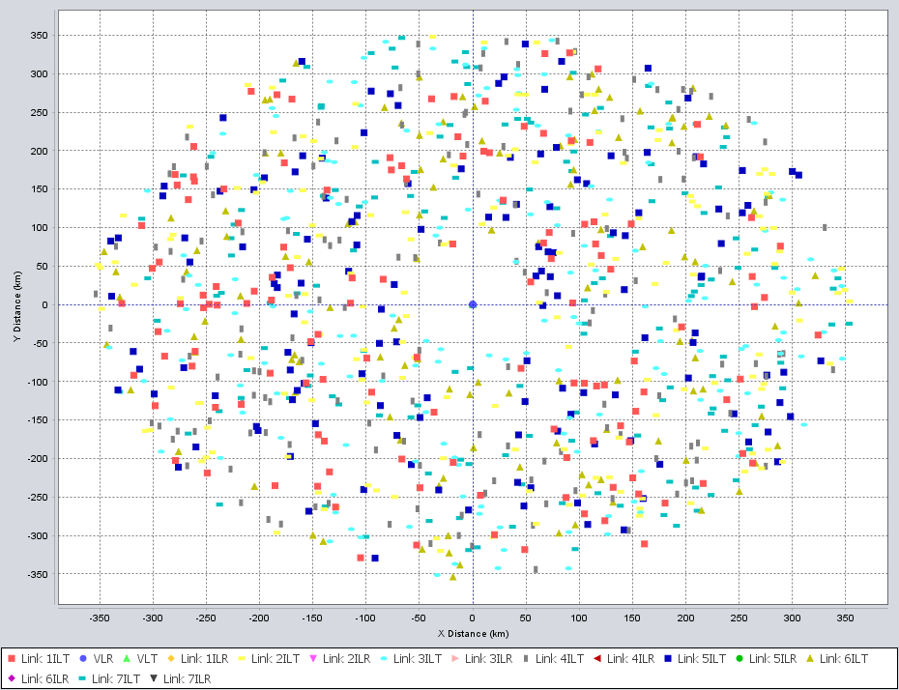
The obtained during the simulation interference values were used to generate CDF distributions, first the collected data after simulation comprised into the probability distribution function (PDF).
The PDF can be integrated into the CDF using:
$CDF(X)=\int_{-∞}^{X}{PDF(x)dx}$
The PDF and CDF data can be generated using the quantized data of the calculated values as histogram H (i) where I = {0 …. n} and each value i can be mapped to a data value x using
$x(i)={xBinSize}_{min}$
The bin relating to data value x is then
$i(x)=Round\left[\frac{x-x_{min}}{x_{BinSize}}\right]$
The probability density histograms for each coordination distance that was analysed (50 km, 60 km, 70 km and 100 km) is provided below in Figure 6.
Figure 6
Interference levels from IMT-2020 to RAS for different coordination distances
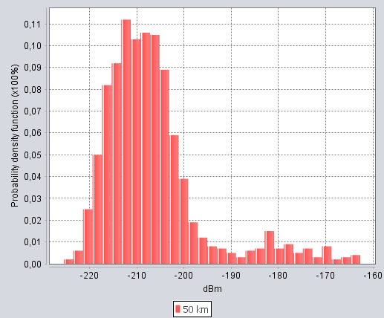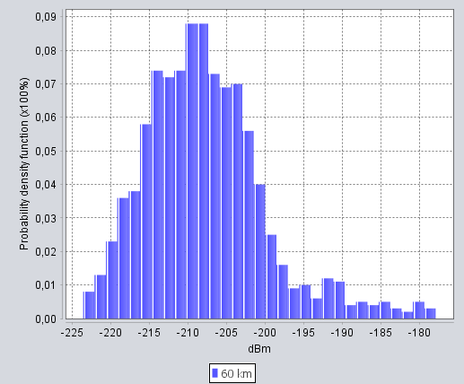
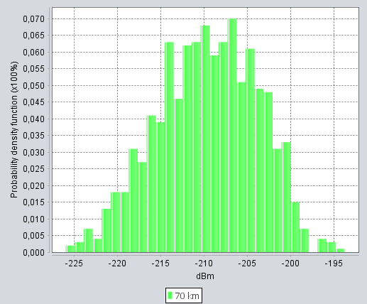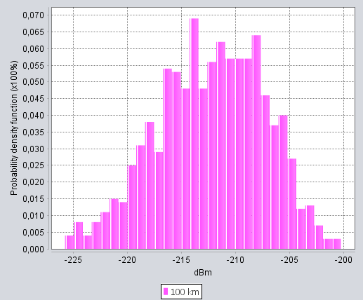
Then the CDF can be generated from the histogram as a percentage using:
$CDF(X)=100\frac{\sum_{i=0}^{i(X)}{H(i)}}{\sum_{i=0}^{i(n)}{H(i)}}$
Figure 7 shows the cumulative distribution function curves for each simulated coordination distance. The red curve represents the CDF for a 50 km coordination distance, the blue curve for a 60 km coordination distance, the green curve for a 70 km coordination distance, and the purple curve for a 100 km coordination distance.
Figure 7
Interference levels from IMT-2020 to RAS for different coordination distances
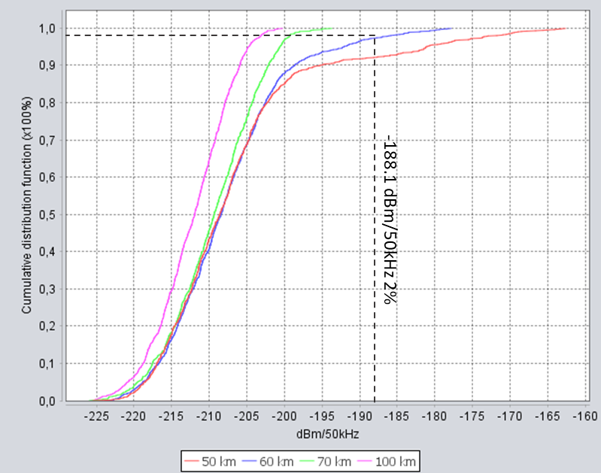
As may be seen from the curves the minimum coordination distance that allows to protect RAS from aggregate interference of IMT with urban deployment is 60 km.
Sensitivity analysis study
Resolution 220 (WRC-23) has adopted expected EIRP mask to ensure protection for the FSS (Earth-to-space). This mask is based on the simulation studies of the WRC-23 cycle.
Averaging over beamforming directions for a given vertical angle θ₀ and horizontal angle φ₀: for an AAS base station within a given horizontal and vertical steering range, a sufficient sampling of N beamforming directions (α_{n}, β_{n}) n = 1 ... N is necessary to allow an accurate averaging of the expected e.i.r.p.
The beamforming directions (α_{n}, β_{n}) have a uniform statistical angular distribution within the steering range of the IMT base station. In other words:
$P_{1}(θ_{0},φ_{0})=\sum_{n=1}^{N}{w_{n}P(θ_{0}},φ_{0};α_{n},β_{n})$
where wn refers to the weight for the nth beamforming direction, i.e. the fraction of the steering range represented by the n^{th} beamforming direction. For example, wn = 1/N in the case that N uniform equispaced beams are assumed in the azimuth and elevation, respectively, and where each beam covers an equal range of angles.
The set of base station configurations over which the base station complies with the limits on expected e.i.r.p. (for example, power of steering range as one of the parameters) shall be declared and the BS shall be used within one of these configurations.
The set of e.i.r.p. values used to calculate the expected e.i.r.p. for each vertical angle range shall be a mathematical summation of both polarization states of the IMT base station antenna with no polarization discrimination. The applied mask is presented in Table 2.
Table 2
IMT technical parameters for base stations and user equipment in the band 6 425-7 025 MHz
Vertical angle range | Expected EIRP  (dBm/MHz)
0º ≤ θ < 5º | 27
5º ≤ θ < 10º | 23
10º ≤ θ < 15º | 19
15º ≤ θ < 20º | 18
20º ≤ θ < 30º | 16
30º ≤ θ < 60º | 15
60º ≤ θ < 90º | 15
NOTE 1: The expected e.i.r.p. is defined as the average value of the e.i.r.p., with the averaging being performed:
– over horizontal angles from −180 to +180, with the IMT base station beamforming in a specific direction within its horizontal and vertical steering range,
– over different beamforming directions within the IMT base station horizontal and vertical steering range, and
– over the specified vertical angle range θL ≤ θ < θH.
NOTE 2: An IMT base station shall comply with the specified limits on expected e.i.r.p. spectral density for all mechanical tilts with which it can be deployed, taking into account considering m).
NOTE 3: See the Annex to this Resolution for additional details on how the expected e.i.r.p. can be calculated for this frequency band.

Given that the interference from BS to RAS will come at the angles slightly above the horizon, this mask can be also adopted to estimate the aggregate interference from IMT to RAS. Figure 8 shows interference levels from IMT to RAS when applied expected EIRP mask for different coordination distances.
Figure 8
Interference levels from IMT-2020 to RAS for different coordination distances
when applying the expected EIRP mask
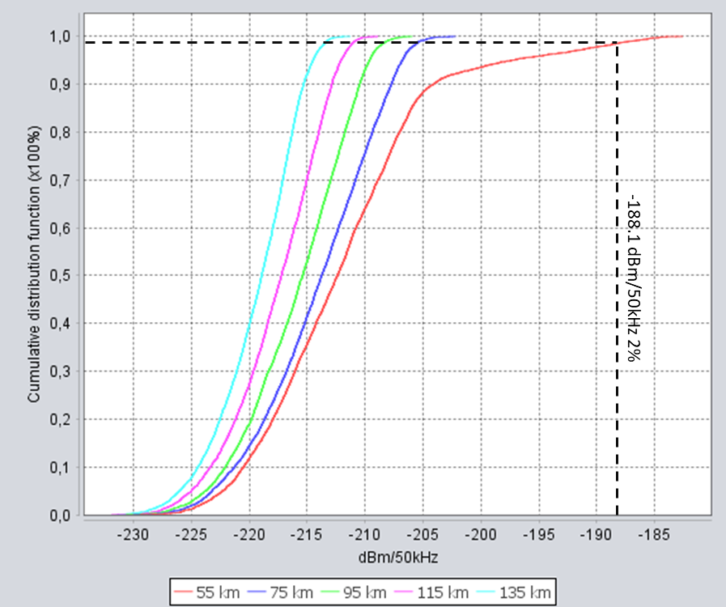
As may be seen from the obtained figures, the required coordination distance to protect RAS from IMT in urban deployment is 55 km.
Site specific study
For this type of the study single-entry interference has been analysed. The BS with suburban/rural deployment has been considered, the clutter hasn’t been applied in the scenario. Propagation mode based on the Recommendation ITU-R P.2001 was used. SRTM terrain was used to take into account the terrain losses. The single-entry interference was calculated using the following expression:
$I=P_{tx}+G_{tx}(θ,φ)+G_{rx}(θ,φ)--L_{2001}-10log⁡(\frac{1}{A_{TDD}})-10log⁡(\frac{1}{A_{loading}})-L_{pol}$
where:
$P_{tx}$: Output power of the BS in dBW
$G_{tx}(θ,φ)$: Antenna gain of the BS towards the RAS station in dBi
$G_{rx}(θ,φ)$: Antenna gain of the RAS towards the BS in dBi
$L_{2001}$: Propagation losses based on the Recommendation ITU-R P.2001
$A_{TDD}$: TDD activity factor, equals 0.75
$A_{Loading}$: Network loading factor, equals 0.5
$L_{pol}$: Polarization difference losses in dB.
It should be noted that in this study polarization loss was assumed 0 dB since there was no information on polarization type the RAS stations could be used. In this example site-specific study, Badary RAS station was considered. The Badary Radio Astronomical Observatory is situated in the Burytia Republic (East Siberia) about 130 km east of Baikal Lake. This example represents a good case since Badary station located not far from the Russian-Mongolian border thus effectively representing possible cross-border example scenario.
Interference levels for inband and adjacent band scenarios are presented in Figure 9.
Figure 9
Single-entry interference to Badary station for the inband and adjacent band scenarios
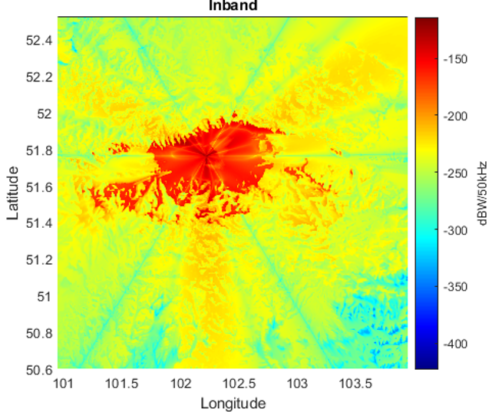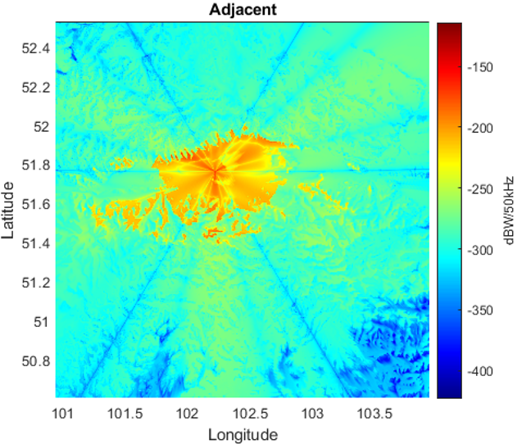
Based on the interference levels, protection contours according to the ‒218.1 dBW/50 kHz can be built. Figure 11 shows protection contours on the SRTM map for the inband interference scenario (red lines), for adjacent channel interference (blue lines).
Figure 11
Protection contours for Badary RAS station for the inband and adjacent domain scenarios
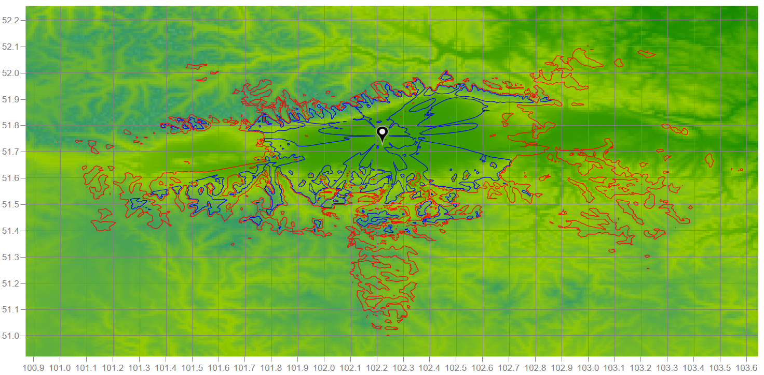
As may be noted, when taking into account terrain shielding, the interference to RAS can be mitigated quite significantly. It should be noted that in case the interfering BS would be shieled by the clutter, the contours would be even smaller, however to address the worst case, this example didn’t take into account clutter losses.
Figure 12 presents protection contours on the Google maps layer where red lines are the contours for the inband interference scenario, green lines are the contours for the adjacent channel interference scenario. On this figure, distance rings are also added to see the coordination distances between BS and RAS that would be required for the site-specific case.
Figure 12
Protection contours for Badary RAS station for the inband and adjacent domain scenarios
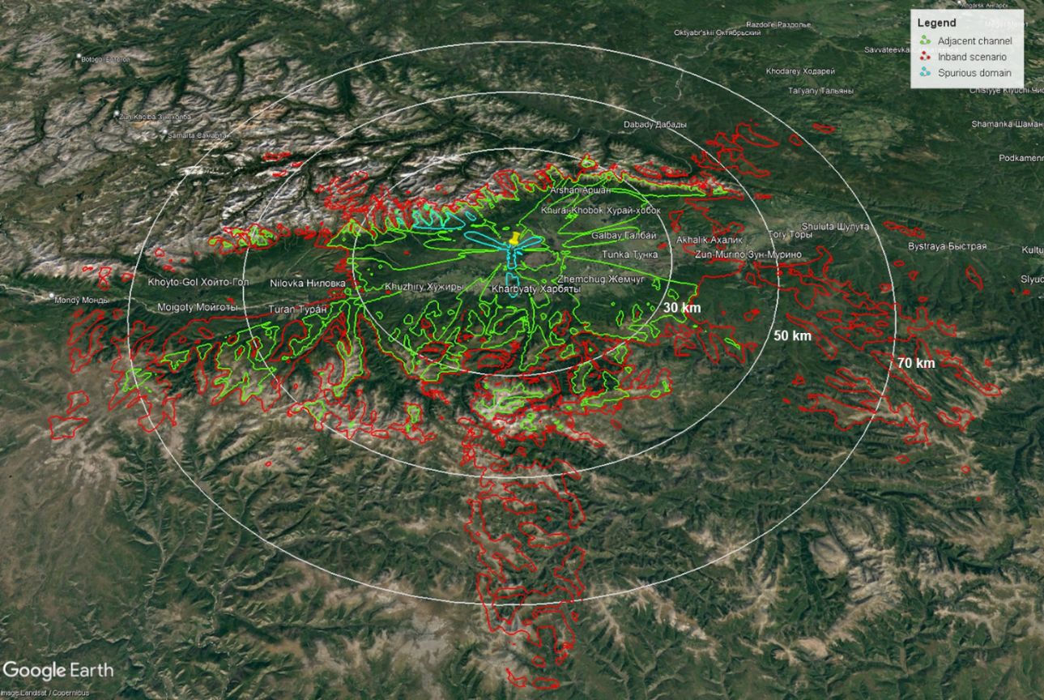
As may be seen from the obtained results, for the case of inband interference the coordination distance would vary from 30 to 80 km, for the adjacent channel scenario it would vary from 10 to 50 km.
Summary
When deploying IMT-2020 in the 6 650-6 675 MHz frequency band, the coordination distances will be largely depended on the deployment scenario of IMT and site-specific environment. For urban deployment, the coordination distance should be 60 km, at the same time when applying the mask that was adopted in WRC-23 for IMT BS, the coordination distance needs to be 55 km. For site-specific scenario when IMT has suburban or rural deployment, depending on the terrain environment, the coordination distance should be from 30 to 70 km, and can be reduced to 10 to 30 km for adjacent channel case.

Annex 4
Proposals on example studies
{Editor note: there are some discrepancies between scenarios and/or assumptions used in this study and those suggested in Document 5D/206. Invite the proponent of this study to check the parameters and provide updated study to next WP 7D meeting in Mar. 2027.}

A.4.1 Introduction
This Annex contains a sensitivity study related to the sharing and compatibility between stations of the terrestrial component of International Mobile Telecommunication (IMT) in the band 6 425-7 125 MHz and RAS in the band 6 650-6 675.2 MHz, which includes sharing and adjacent band scenarios.
Section A.4.2 contains the additional technical parameters for the studies, in case these were not already defined in Section 2 and 3. Section A.4.3 and A.4.4 present generic and site-specific calculations, respectively. In the former case, both single-entry and aggregate scenarios are investigated, while in the latter case only single-entry computations are performed. This is owing to the fact that at the time of writing, no site-specific information on the deployment of IMT equipment in the 6 GHz band was available. Section A.4.5 lists several possible mitigation measures, which could help to reduce the size of coordination zones and minimum coordination distances. A summary is contained in Section A.4.6.
Rural BS is also simulated in the study but IMT base stations in rural areas may not be typical for this 6 425-7 125 MHz frequency band, it’s not expected to be deployed contiguously and any such base stations that may exist in small numbers will be isolated installations at specific locations.

A.4.2 Additional study parameters
The IMT technical parameters used for this study are adopted Section 2 and 3 of this Report. Some additional parameters used in the sensitivity study in this Annex are provided in Table A4-1. The most noteworthy differences are:
– The study is considering a low number of rural BS, and
– Adjacent and spurious domain cases are included, which require the specification BS antenna beamforming efficiencies for these domains.
Antenna pattern parameters for rural BS were assumed to be identical to suburban BS.
Table A4-1
Additional IMT technical parameters for base stations and user equipment in the band 6 425-7 025 MHz
Parameters | IMT Base station | IMT User equipment
Antenna parameters (Rec. ITU-R M.2101-0)
Beamforming efficiency² | ρ = 1.00 (in-band)  ρ = 0.95 (adjacent)  ρ = 0.80 (spurious) | N/A
Down-Tilt | 6° (Rural) | N/A
Antenna height | 25 m¹ (Rural) | 1.5 m
Fraction of below-rooftop installations | 0% (Rural) | N/A
Deployment
Ra (ratio of hotspot area to housing area) | 10%¹ (Rural)
Deployment density in hotspot area (number of sectors; 3 sectors per BS position) | 0.006 km^{–2} (Rural) | 3 UEs per BS sector
Fraction of indoor devices | N/A | 50%¹ (Rural)  70% (Suburban)  70% (Urban)
Distribution of user equipment (relative to base station)
BS cell radii (ISD) | 0.9 km¹ (Rural)
Distance distribution⁴ | Rayleigh(0, 300) (Rural)
¹ Rural parameters were mostly undefined for the IMT band 6 425-7 025 MHz in Document 5D/716 (Annex 4.4).
² Composite antenna pattern (beamforming) efficiency is still significant in adjacent and (near) spurious domain; see 3GPP TR 37.840 (Table 5.4.4.2-3). However, the values that are used for ρ in this study where not specified in Document 5D/716 (Annex 4.4).

A.4.2.1 Base stations
The base stations utilize arrays of antenna elements (with two polarizations). For frequencies in the 6 425-7 025 MHz range, each of the 8 × 12 elements (for each polarization) has a conducted power of Ptx = 22 dBm / 100 MHz and phases can be fully controlled for each element.
For the out-of-band case, the considered RAS frequency band can either be in the adjacent or spurious domain with respect to the MS frequency band. The typical out-of-band conducted powers of IMT-2020 devices in the investigated frequency range are summarized in Document 5D/716 (Annex 4.4) and references therein. The parameters are included in Table A4-1 for convenience. It is noted that the Ohmic losses (2 dB), which usually need to be considered when determining the radiated power from the conducted power, are already included in the element gain, G_{e}. The spurious emission (conducted) in the RAS frequency band is –30 dBm/MHz, while in the adjacent band it is −4 dBm/MHz.
For the compatibility calculations the composite antenna pattern introduced in Recommendation ITU-R M.2101-0 is to be used, which depends on the position of the formed beam. Figure A4-1 shows the pattern for the 6 425-7 025 MHz band for a number of different beam steering angles. In practice, the beam-forming will still be more or less effective even in the adjacent and spurious domains. To account for this, 3GPP TR 37.840 (Table 5.4.4.2-3) introduces a parameter, ρ, which can be used to control the beamforming efficiency. For in-band cases, it should be set to One, while numbers smaller than One make the beamforming less effective. Document 5D/716 (Annex 4.4) does not specify the values that should be used in studies, which is why some (reasonable) numbers have been assumed, here.
For BS, different antenna heights have to be considered, depending on the environment (rural, urban or suburban). To improve the gain after beam-forming, the arrays are furthermore mechanically down-tilted with respect to the horizon. A fraction of BS antennas is assumed to be installed below the rooftops of houses. This has impact on the clutter loss; see below.
Figure A4-1
Composite BS antenna pattern (urban) for different beam steering angles
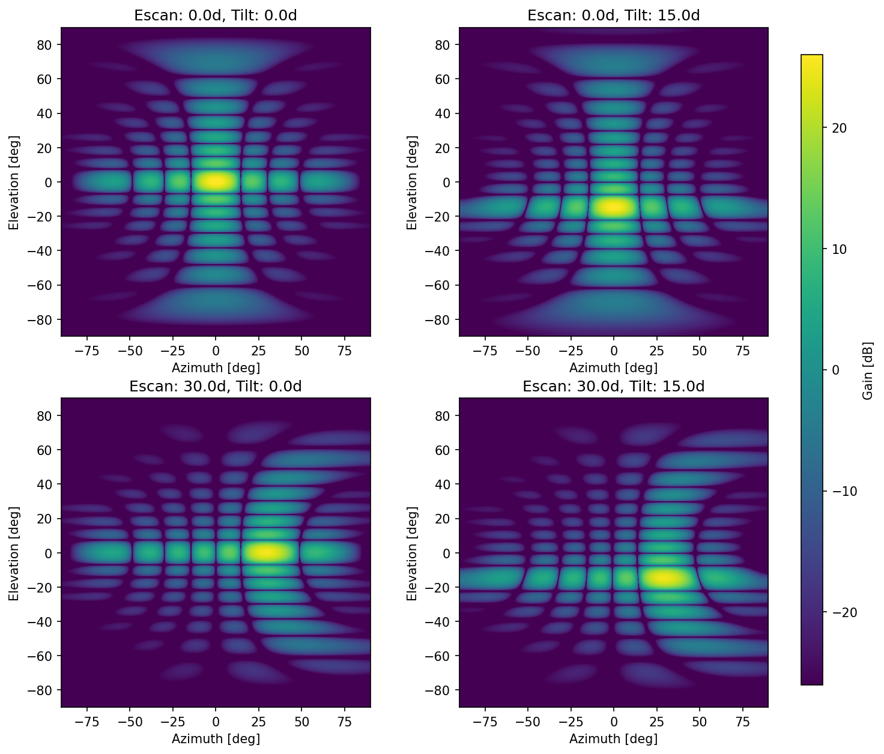

A4.2.2 User equipment
Different to the base stations, the UE does not feature AAS. For the compatibility studies, on average −4 dBi antenna gain is assumed (i.e., quasi-isotropic), with a conducted power of 23 dBm / 100 MHz. As for the base stations, conducted power levels for the adjacent and spurious domain are included in Table A4-1. Additionally, 4 dB body absorption loss must be applied.
A significant fraction of UE devices is assumed to be indoor. In the subsequent calculations, the fraction of UE, which is indoor, has been neglected from the contribution to the total aggregated received power at the RAS receiver.
UE devices feature a power control mechanism; see 3GPP TR 38.901, Table 7.4.1-1. The better the link budget the less UE power is used for transmissions. The power control parameters are also included in Table A4-1.

A4.2.3 Propagation and clutter models
For the generic compatibility study performed in this Report, a flat terrain (i.e., zero terrain heights) is assumed. The propagation model according to Recommendation ITU-R P.452-17 is used. For BS, where AAS are in use, the position of the formed beam changes the effective gain towards the RAS station. Parameter p (“time-percent”), as defined in Recommendation ITU-R P.452-, was assumed not to be exceeded for 2% of the time, following recommends (2) of Recommendation ITU-R RA.1513.
For the deployment of IMT equipment around RAS stations, case studies for individual RAS stations may be required, which can only be performed using detailed and specific information about actual deployment of BS around a RAS station.
For the prediction of clutter loss Recommendation ITU-R P.2108 (Section 3.2) was used. This model depends only on frequency, distance and the location percentage, p_{L}. The latter quantity is to be understood as the percentage of emitters (spread across an urban or suburban zone) producing the lowest clutter loss. For example, if p_{L} is 2%, the value $L_{cl}$ returned by the method indicates that for 2% of all cases the clutter loss will be lower than $L_{cl}$.
At 6.65 GHz and for distances larger than 5 km, clutter loss values for p_{L} = 2% are about 19 dB and about 31 dB for p_{L}=50%, respectively, whereas Recommendation ITU-R P.452 predicts up to 20 dB clutter attenuation. In the case of aggregate emissions, an integration of received powers over a sufficiently large area will be performed. Therefore, by assigning random (uniformly distributed) p_{L} values, ranging from 0% to 100%, to each BS and UE device, the expectation value of the clutter loss distribution can be computed. For distances larger than 5 km this is about 27 dB at 6.65 GHz. It is noted that for single-entry (worst-case) calculations, no clutter loss should be assumed, as there is always a non-negligible chance for the transmitter to be unaffected by clutter.
Furthermore, only a fraction of BS antenna installations is expected to be below the roof-tops of housings. All other BS locations will not be subject to relevant clutter loss. In particular, for rural locations, all BS will be at significantly larger heights than the typical roof heights. While Recommendation ITU-R P.2108-0 (Section 3.2) must only be used for urban and suburban areas, it is here also applied to UE in rural areas, as the UE are at low heights of 1.5 m.
Typical atmospheric conditions (temperature: 20°C, pressure: 1 013 mbar) were assumed. For IMT equipment, the path attenuation is dependent on the associated zone (urban/suburban/rural), as the typical antenna height is different. The resulting path attenuation values are displayed in Figure A4-2 for UE and BS, respectively.
Figure A4-2
Path attenuation for BS and UE in the 6 425-7 025 MHz band as a function of distance
to the RAS station obtained using Recommendation ITU-R P.452-16
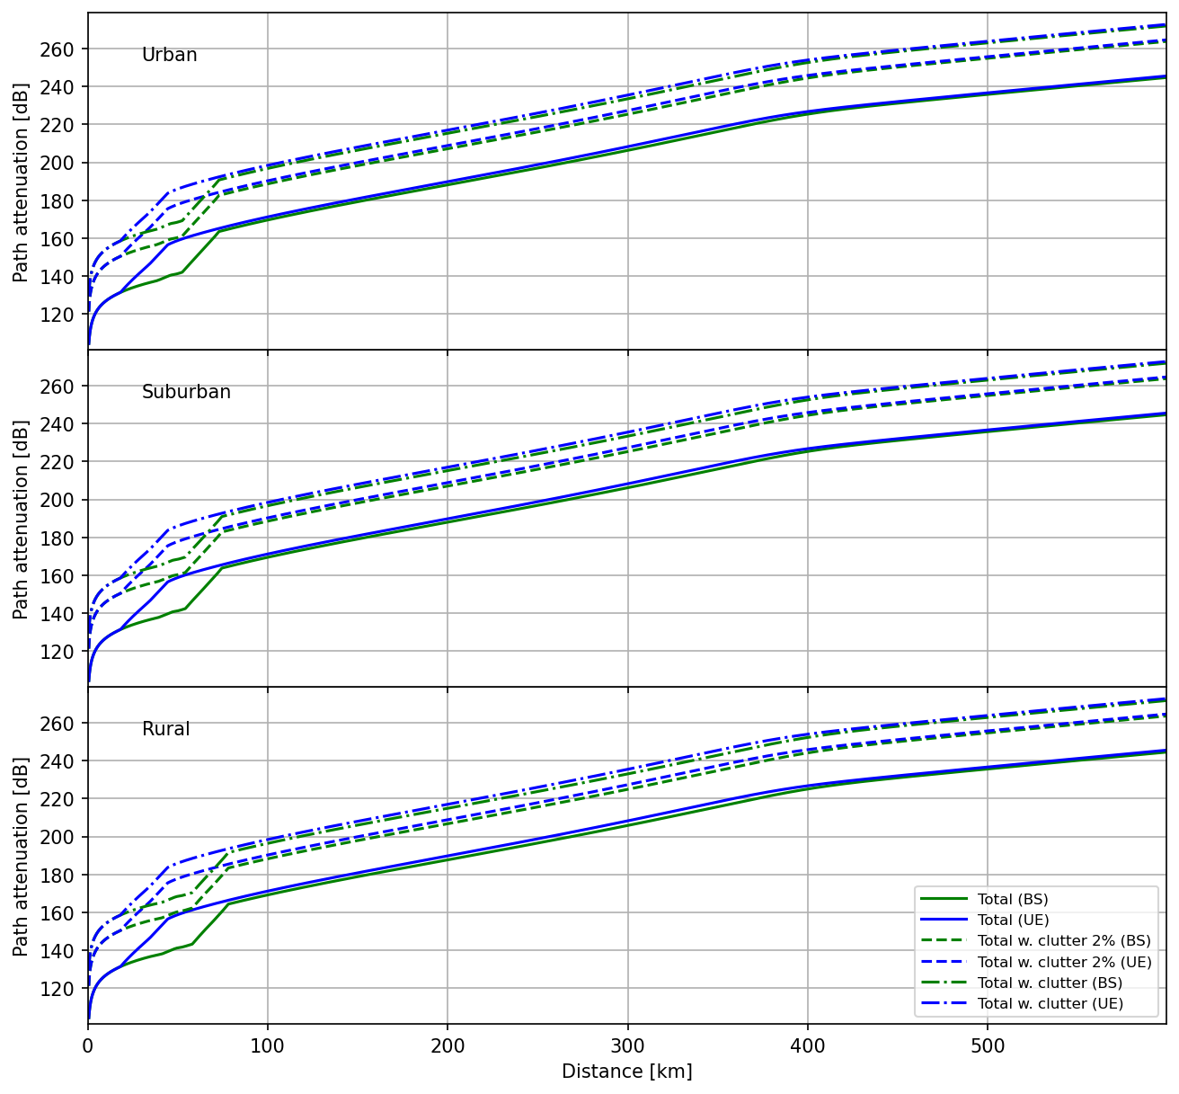

A4.3 Generic compatibility studies
For the single-interferer case the situation of a BS or UE device pointing directly towards the RAS station is of main concern. As a fair fraction of the BS is installed above roof-tops, it must be assumed that in the worst case, no additional clutter loss would apply. That no clutter loss is experienced is potentially also true for UE, although this is somewhat less likely to occur than for BS. Nevertheless, for the sake of comparison also the results under different assumptions for the clutter loss are provided here as well.

A4.3.1 Worst-case single interferer scenario
In the case of base stations, the down-tilt of the transmitting antenna arrays has to be accounted for (between 3° and 10° depending on the frequency band and environmental zone). Using the given antenna patterns (see e.g. Figure A4-1), the gain towards the RAS station was calculated under the assumption that the beam is steered towards the RAS receiver or –for trans-horizontal propagation paths– towards the local horizon as seen from the BS. In combination with the total power transmitted into the RAS frequency band and the total path attenuation, the power received at the RAS station can be determined. The results are visualized in Figure A4-3 to Figure A4-5 for the different cases (in-band sharing, adjacent band operation, and spurious domain).
The horizontal dashed red line indicates the Recommendation ITU-R RA.769 power threshold level for detrimental interference. The interception of the received power plots with the dashed red line therefore defines the radius of the coordination zone that would be necessary to protect the RAS station. The required coordination distances depend on the frequency, the environmental zone and the assumed clutter loss, but exceed 250 km in all cases and even exceed 400 km in some cases for the in-band sharing and are up to about 250/100 km for adjacent/spurious band operation, respectively.
The results for UE are also included in Figure A4-3 to Figure A4-5. Here, the necessary coordination zone sizes are up to 75 km (in-band sharing) and about 50/25 km (adjacent/spurious), respectively.
Figure A4-3
Single-interferer worst-case scenario (in-band sharing) in the 6 425-7 025 MHz band
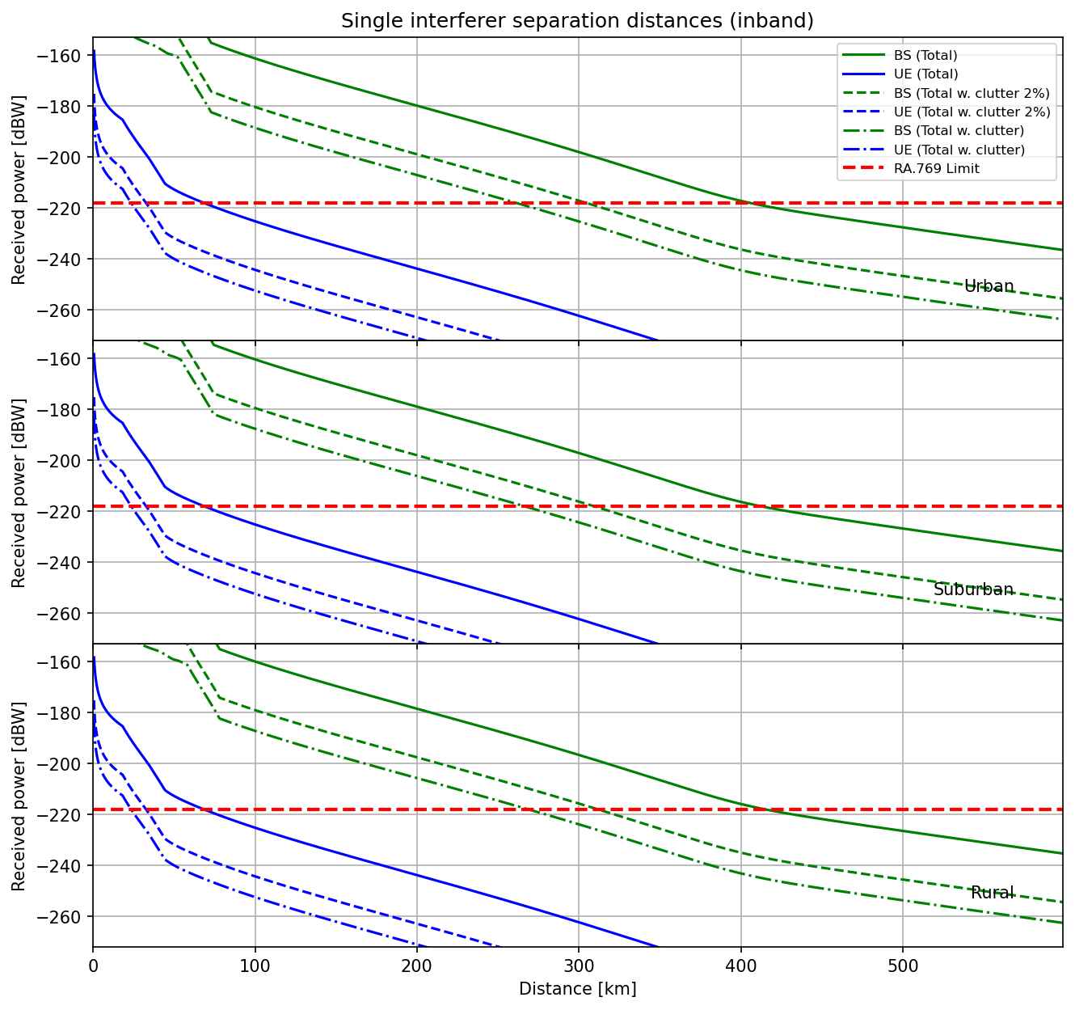
Figure A4-4
Single-interferer worst-case scenario (adjacent band operation) in the 6 425-7 025 MHz band
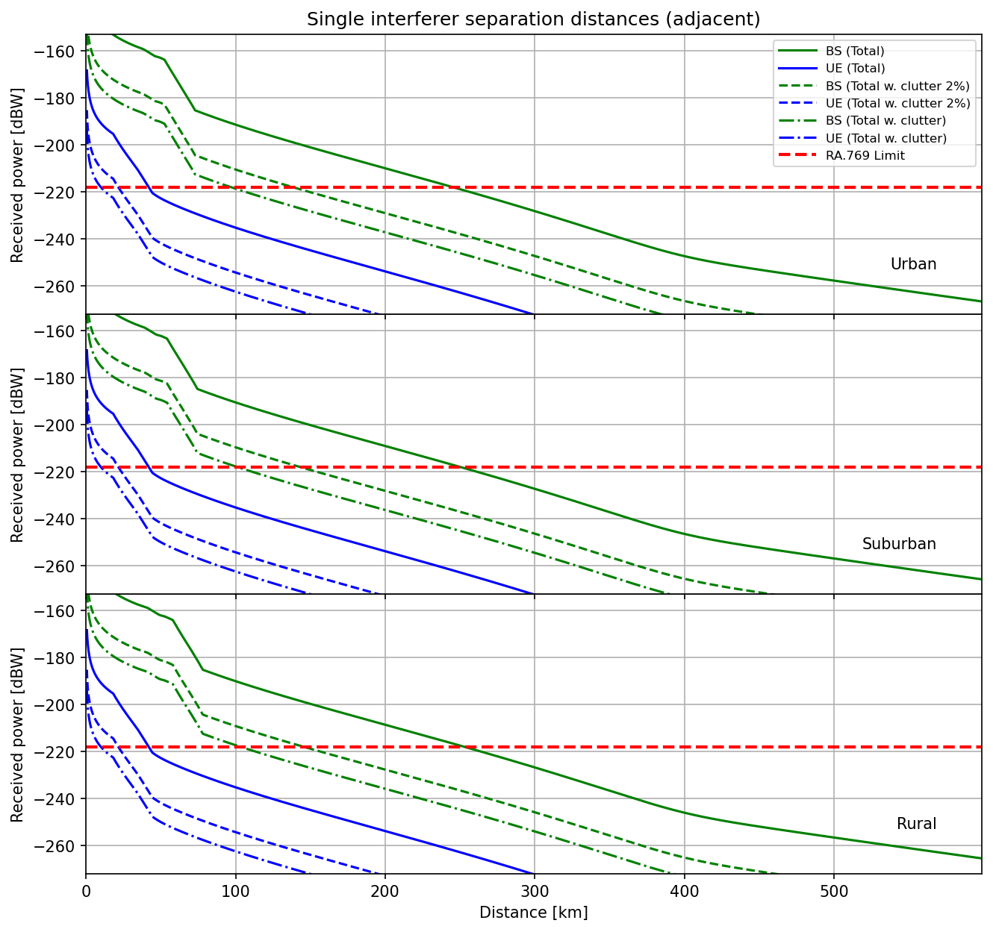
Figure A4-5
Single-interferer worst-case scenario (RAS in spurious domain of IMT) in the 6 425-7 025 MHz band
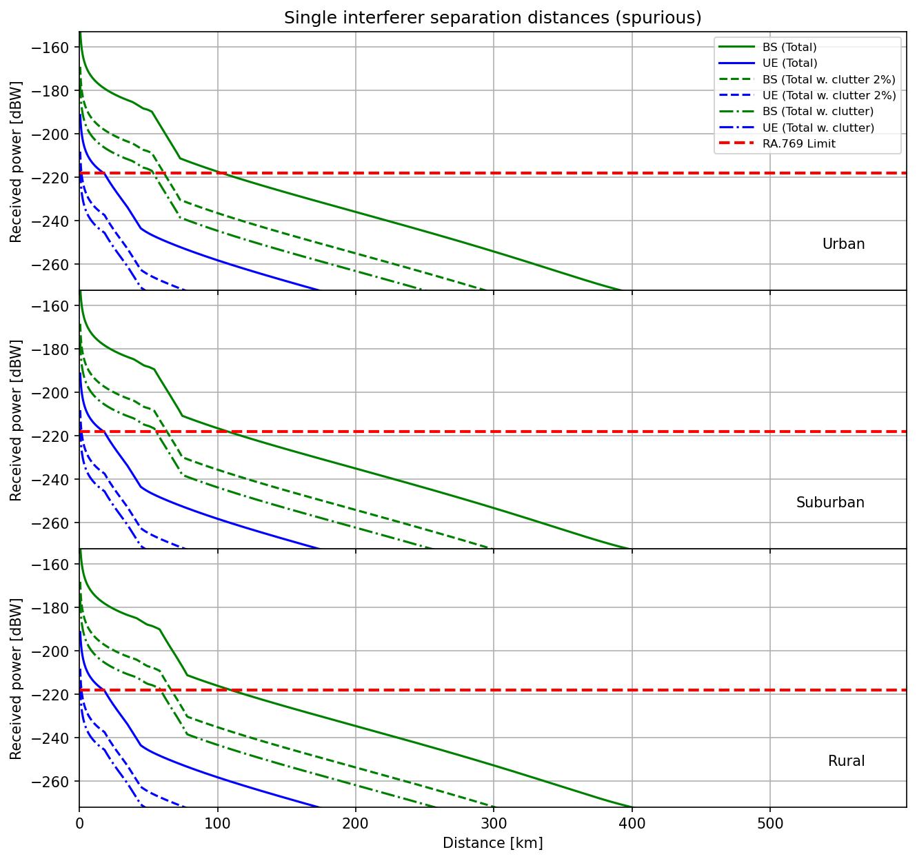

A4.3.2 Aggregated scenario
Not only the single-interferer scenario has to be considered for a compatibility study, but also the aggregated power scenario, which considers the impact of the accumulated emitted power of all IMT devices around an RAS station. Here a Monte Carlo simulation is used to infer the total aggregated power of an ensemble of BS and UE devices, which are located randomly in a box of sufficient size, adhering to the given distribution functions describing the typical deployment of devices.

A4.3.2.1 Deployment of IMT equipment
In Recommendation ITU-R M.2101-0 several possible deployment topologies for IMT networks are discussed, such as hexagonal or Manhattan-style grid layouts. Typical deployment number densities and other technical parameters are provided in Document 5D/716 (Annex 4.4).
In the particular case that is analysed here, the network topology can be neglected because one needs to average over a very large region. Then, the aggregated power at the RAS station will be completely determined by the average deployment densities defined in Document 5D/716 (Annex 4.4) (per zone type: urban, suburban and rural).
Following Document 5D/716 (Annex 4.4), it is assumed that parameter R_{b} = 5% (percentage of the considered area which has housing), and that R_{a} = 60%, 30%, and 10% for Rural, Suburban, and Urban areas, respectively. For urban zones, 10 BS sectors per square kilometre are expected, with three sectors per BS position, i.e., the number of BS is 10/3 km⁻². For rural and suburban zones, the BS (sector) density is lower with 0.006 and 2.4 km⁻². In all zones, it is expected that each BS sector will serve 3 UEs (simultaneously).
In practice, urban and suburban areas in a region are often clustered. Since no distribution functions for the BS and UE device locations to be used in generic studies were specified so far, a uniform distribution is used here as a reference. Nevertheless, to analyse the impact of clustering effects, the following simple algorithm could be used to produce a typical distribution of urban and sub-urban zones in a densely populated environment such as Central Europe.
First, a rectangular grid of 600 km × 600 km with cells of size 2 km × 2 km is produced. For each cell a random number is drawn from a normal distribution. The uniform-density generation of urban and suburban cells is possible by computing appropriate percentiles: all cells with a random value above $(100\%-{(R}_{a}^{urban}+ R_{a}^{suburban})R_{b})$ are classified as suburban, while cells with random values above $(100\%-R_{a}^{urban}R_{b})$ are classified as urban. The result of this is visualised in Figure A4-6 (left panel). For the central 100 km × 100 km of the simulated box. To achieve a clustering effect, a correlation length between adjacent pixels has to be introduced. This is possible by smoothing the original grid of random numbers with a blurring filter, e.g., a Gaussian filter. To achieve a realistic effect, three different kernel scales, σ_{k}, and relative amplitudes were used simultaneously: σ_{k} =2 km, 5 km and 15 km with relative amplitudes of 30%, 30% and 40%. Calculating distribution percentiles of the smoothed random number field leads to the classification of zone types representing a clustered environment, displayed in Figure A4-6 (right panel).
Figure A4-6
Sampling of the different zone types. Left: Uniform distribution. Right: Clustered distribution
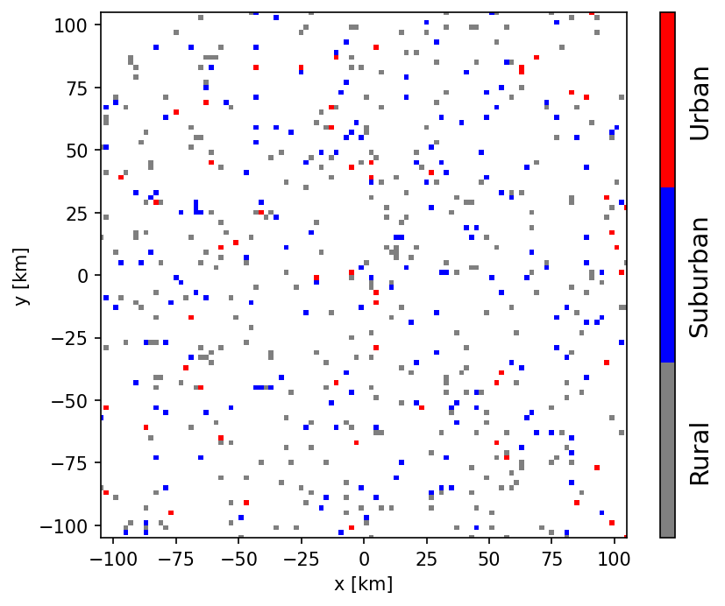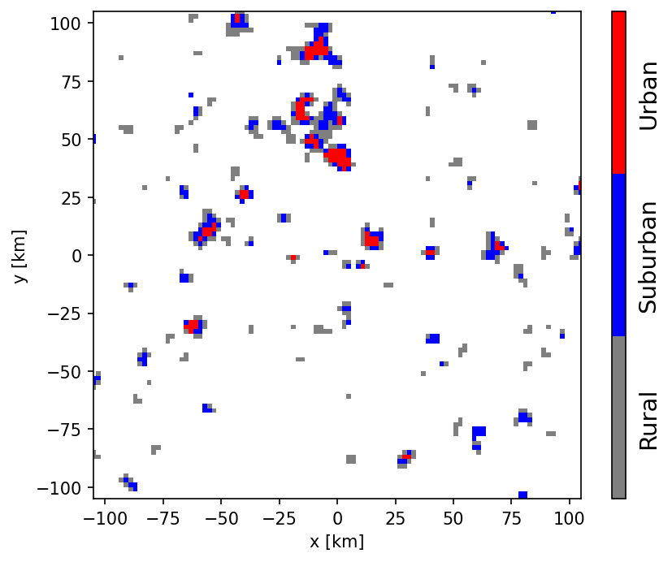
The Monte Carlo method used here to calculate the aggregate power is straightforward: BSs are randomly sampled into rural, suburban, and urban zones until the number of devices per zone leads to the specified BS number density. As an example, for a box of 1 000 km × 1 000 km this leads to 6667 BS (20 000 sectors) in urban, 800 BS (2 400 sectors) BS in suburban, and 4 BS (12 sectors) in rural zones. To each BS a random azimuthal orientation (bearing) is assigned, and it is assumed that the three sectors per BS are spaced by 120°.
In each sector, three UEs are active. From the perspective of a base station sector, the UE devices are distributed in a forward cone. Here, radial and angular distribution functions are assumed as defined in Section 2. The distance between BS and UE is given by a Rayleigh distribution. The angular distribution is given by a uniform distribution within ± 60°. The combination of both distributions defines the desired forward cone.
UE devices can be rotated randomly, but as a constant antenna gain of −4 dBi is assumed, this has no impact on the simulations.

A4.3.2.2 Effective antenna gains and propagation losses
To infer the effective antenna gains of the BS toward the RAS station it is necessary to calculate the directions to the associated UE devices (yielding the Az_{i} and El_{i} steering direction of the beam), as well as to the RAS receiver, both in the antenna reference frame. These directions also play a role for the UE power control algorithm that is based on the coupling loss between UEs and BS. Hence, the effective gain of the BS array-antenna beams needs to be considered. As the BS (and UE) antenna frames are rotated and tilted the calculations are best performed using 3D vector algebra and appropriate rotation matrices. For determining the direction to the RAS station, it is furthermore necessary to account for the path propagation horizon angle derived from the propagation loss calculation. In Figure A4-7, an example configuration is visualized. Stars and filled circles show positions of BS and UE respectively, whose colours indicate the resulting antenna gain (in dBi) as indicated by the colour bar shown in the figure.
Red lines show the vectors between UEs and their BSs. Black arrows indicate the antenna frame normal vectors, while grey arrows show the direction to the RAS receiver. It is noted that only a projection onto the x-y plane is visualized, although 3D vectors are used throughout the simulation. As the length of all arrows is equal in 3D, the apparent length of the arrows in Figure A4-7 is an indicator of their z-component.
On average, one finds that the resulting effective antenna gain towards the RAS station increases, the better the vector between UE and BS aligns (red lines) with the vector to the receiver (grey arrows). However, the orientation of the transmitting antenna arrays (black arrows) plays a role, as well, because it changes the side-lobes of the formed beam. For example, a rotation about the forward direction (defined by the antenna normal vector) will only mildly change the forward gain but can have significant impact on the gain into any other direction.
One detail which needs to be considered to calculate the BS gain for the composite-array scenario, is that one BS serves three UEs. The effective BS gain was determined by averaging over the individual gains resulting from the beam pointing to the distinct UE devices.
The propagation losses can simply be derived from the Recommendation ITU-R P.452-prediction over the distance given by the respective grid cell to the map centre (where the RAS station is situated). As discussed above, the clutter losses are calculated by assigning a random value to p_{L} (uniformly distributed over the range 0% to 100%).
Figure A4-7
Example of a BS-UE configuration (zoom-in) for the simulation
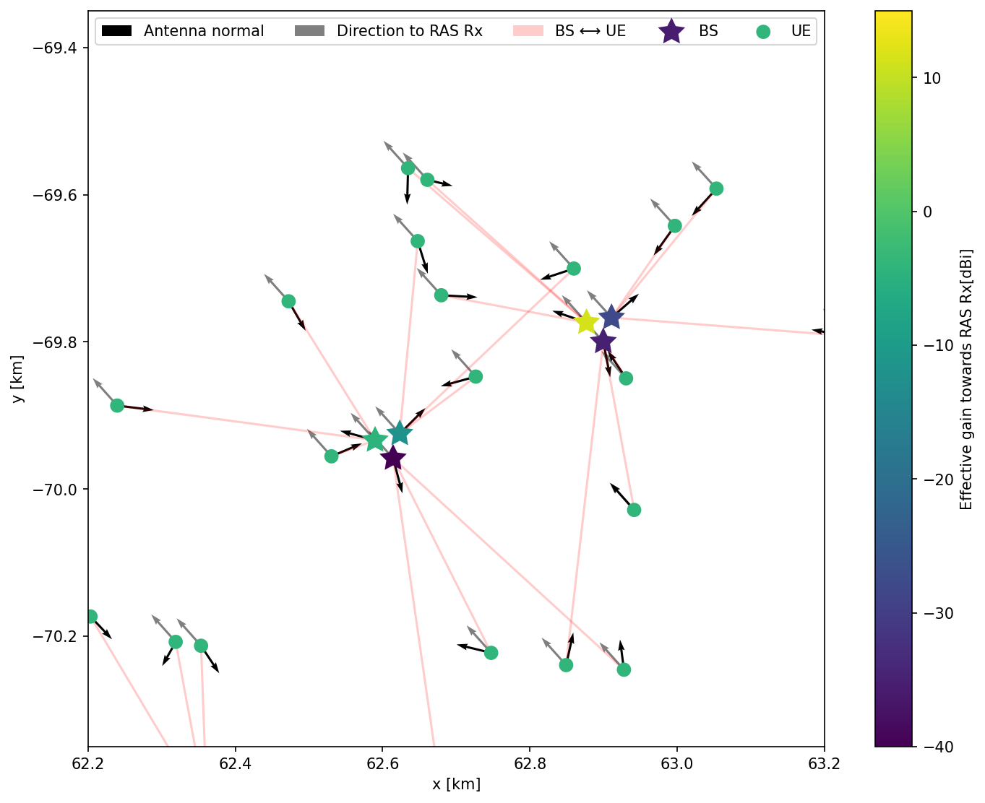

A4.3.2.3 UE power control
IMT-2020 user equipment is subject to power control. Depending on the distance of each UE device and path type (LoS, Non-LoS) its output power can be increased or decreased for efficient use of power consumption. Furthermore, the number of other active devices in the vicinity plays a role in the power control algorithm, as described in Recommendation ITU-R M.2101-0. The path propagation loss between UE and their associated BS is calculated according to the equations given in 3GPP TR 38.901, Table 7.4.1-1 (RMa/Uma – Rural/Urban Macro scenarios). For the power control algorithm, the coupling loss has to be applied, which is the path propagation loss combined with the effective gains of the formed beams of the BS AAS. In Figure A4-8, the effect of the power control on the UE output levels is visualised: the UE devices are coloured according to the difference (in dB) in output power after the power control algorithm was applied with respect to the nominal output power.
Figure A4-8
Effect of UE power control for the example configuration shown inFigure A4-7.
Difference (in dB) in output power after application of the power control algorithm
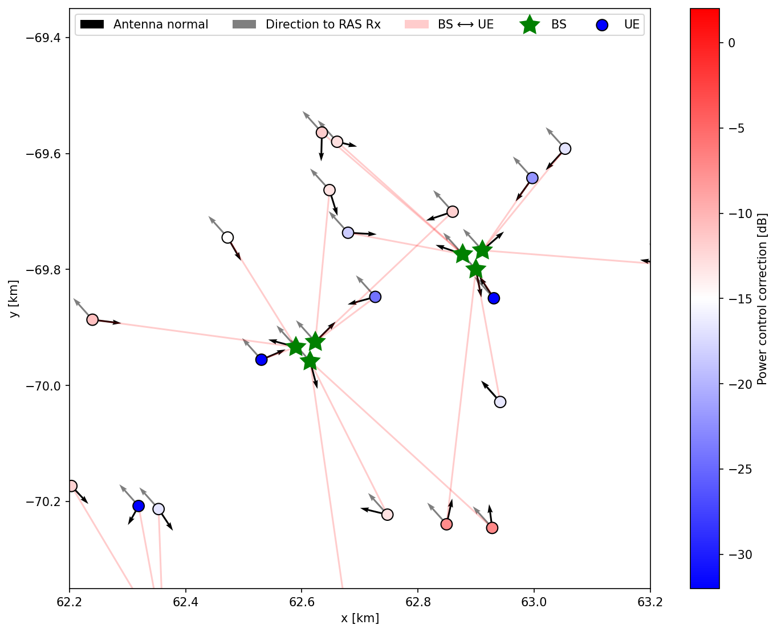

A4.3.2.4 Integrated power at the RAS receiver
Each Monte Carlo iteration (i.e., one realization of a BS+UE configuration within the box) yields a total power level received at the RAS station, which is calculated by simply aggregating all individually emitted power levels and accounting for antenna gains and propagation loss. In practice, in effectively all cases the RAS interference threshold levels are exceeded.
A minimal coordination distance can be calculated by determining the received power as a function of a coordination distance (exclusion radius) R_{i}. For each R_{i} the total contribution of devices outside a circular zone of radius R_{i} is inferred. As this is performed for each iteration, an ensemble of curves (received power as a function of coordination distance) is generated. By studying the distribution percentiles, the 50% (median) or highest 2% curve can be extracted. The latter matches the highest acceptable data loss for the RAS, following Recommendation ITU-R RA.1513. The minimal coordination distances are defined by the crossing points of the received-power curves with the threshold power level for detrimental interference given in Recommendation ITU-R RA.769.
For each of the deployment scenarios (uniform density and clustered), as well as for the adjacent, spurious, and in-band domain a Monte Carlo simulation was carried out. In Figure A4-9 to Figure A4-12, the ensemble curves and distribution percentiles are displayed for the various scenarios. Again, for the in-band case, very large coordination distances (about 400 km) would be necessary to protect RAS operations. Even for the spurious cases, the distances significantly exceed 50 km. The UE are completely insignificant for the total aggregated received power. It can also be seen that the deployment (uniform density vs. clustered) does not play a significant role as the relevant area in the simulations is so large that any “small-scale” structures in the deployment is marginalized.
Figure A4-9
Results for the aggregated scenario in the 6 425-7 025 MHz band
(each simulation run is drawn separately, uniform deployment)
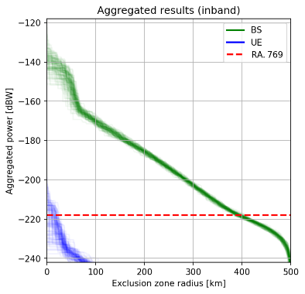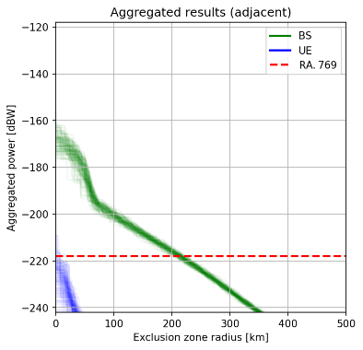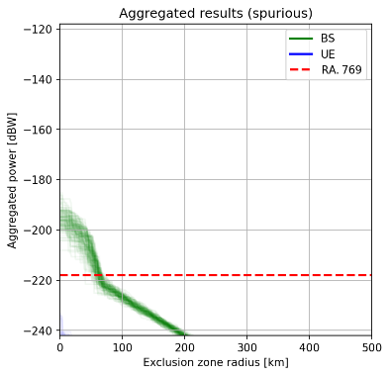
Figure A4-10
Results for the aggregated scenario in the 6 425-7 025 MHz band
(distribution percentiles of results inFigure A4-9, uniform deployment)
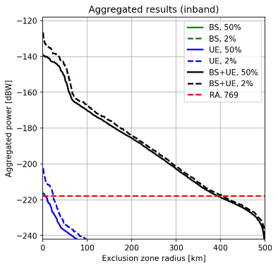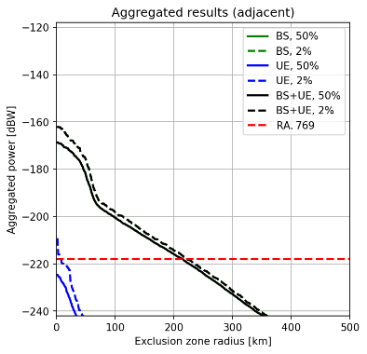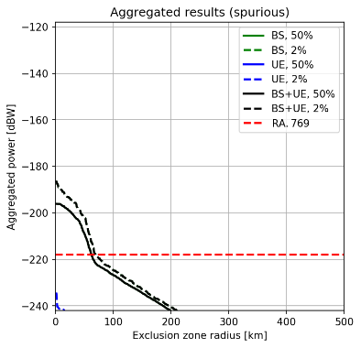
Figure A4-11
Results for the aggregated scenario in the 6 425-7 025 MHz band
(each simulation run is drawn separately, clustered deployment)
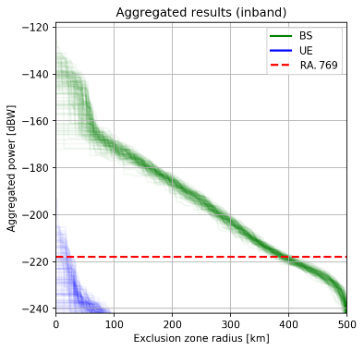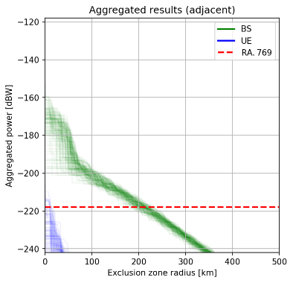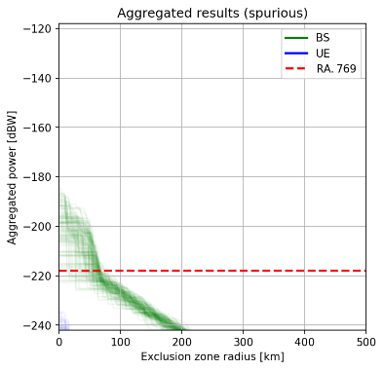
Figure A4-12
Results for the aggregated scenario in the 6 425-7 025 MHz band
(distribution percentiles of results in Figure A4-11, clustered deployment)
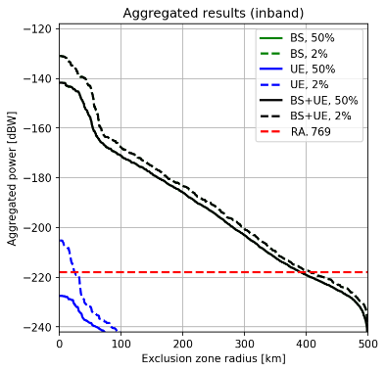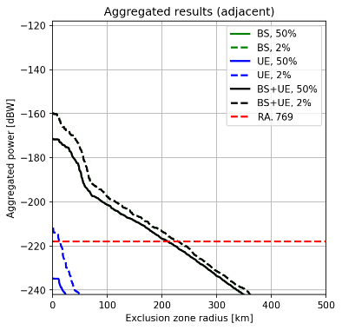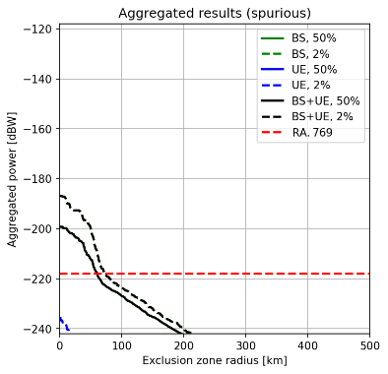

A4.3.2.5 Summary of aggregation calculations
The resulting coordination distances for all scenarios are summarized in Table A4-2 to Table A4-4.
Table A4-2
Coordination distances for in-band sharing in 6 425-7 025 MHz
Zone | BS (km) | UE (km) | BS+UE (km)
Single-interferer worst-case scenario
Urban | 405 | 68 | N/A
Suburban | 412 | 68 | N/A
Rural | 415 | 68 | N/A
Aggregated scenario
Uniform deployment (2% / 50%) | 406 / 395 | 24 / 6 | 406 / 395
Clustered deployment (2% / 50%) | 407 / 392 | 25 / 1 | 407 / 392

Table A4-3
Coordination distances for adjacent band operation in 6 425-7 025 MHz
Zone | BS (km) | UE (km) | BS+UE (km)
Single-interferer worst-case scenario
Urban | 245 | 42 | N/A
Suburban | 250 | 42 | N/A
Rural | 253 | 42 | N/A
Aggregated scenario
Uniform deployment (2% / 50%) | 223 / 216 | 9 / 1 | 223 / 216
Clustered deployment (2% / 50%) | 230 / 211 | 12 / 1 | 230 / 211

Table A4-4
Coordination distances for spurious domain results in 6 425-7 025 MHz
Zone | BS (km) | UE (km) | BS+UE (km)
Single-interferer worst-case scenario
Urban | 103 | 17 | N/A
Suburban | 107 | 17 | N/A
Rural | 109 | 17 | N/A
Aggregated scenario
Uniform deployment (2% / 50%) | 70 / 63 | 1 / 1 | 70 / 63
Clustered deployment (2% / 50%) | 70 / 63 | 1 / 1 | 70 / 63

A4.4 Site-specific studies

A4.4.1 Worst-case single interferer scenario
To complement the generic (flat-terrain) sharing and compatibility studies in Section A4.3, in the following site-specific single-interferer coordination distances will be derived for some real RAS sites, accounting for real terrain around the sites. The example sites are (1) the 100 m radio telescope at Effelsberg (DEU), (2) the Jodrell Bank Observatory (UK), (3) the Sardinia Radio Telescope (IT), and (4) the Yebes 40 m observatory (ESP). These sites represent only a small selection of European sites, which can observe in the 6.6 GHz band. There are, for instance, methanol observations are also being made in Latvia, Finland and Poland, and forming core research programmes for those stations. However, the chosen sites represent a sample of varying terrain conditions and thus serve as good indicators.

A4.4.1.1 Study parameters
The study parameters were provided in Section 2. In contrast to the approach for aggregated calculations (compare Section A4.3.2), in those scenarios where clutter losses are included, a typical value of the Rec. ITU-R P.2108-0 (their Section 3.2) clutter loss model must be used. This is obtained by averaging over a uniform distribution of p_{L} values (i.e., it is the expected value of the clutter loss). This average clutter loss amounts to about 27 dB. Again, it must be noted, that the model in P.2108 is appropriate for urban and suburban land cover types and only if the IMT devices are below the rooftops of the housings. As in some countries, these conditions may not be fulfilled when assignments are made, the results for zero clutter loss values will also be provided for comparison.

A4.4.1.2 Singe-interferer scenario
The method to derive single-interferer coordination distances for the in-band, as well as adjacent and spurious-domain cases is the same as in Section A4.3.1. The only difference is that here the actual terrain heights around the sites of interest are considered in the application of the path propagation model (Rec. ITU-R P.452). The results are shown in Figure A4-13 to Figure A4-15 and were only calculated for an antenna height of 25 m (rural). While installations in urban/suburban areas may have slightly lower antenna heights, the difference in the results is marginal. For all sites, SRTM data were used, which provide terrain height information with high spatial resolution.
Again, the assumption was made that the BS antennas are tilted down and that the beam never points above the horizon. However, this restriction does not lead to significantly reduced coordination zone sizes, which was tested by comparing the results to a case where the maximum BS antenna gain was used. Only in very mountainous terrain it can make a difference, in more open terrain, the typical horizon elevation angles are too close to zero to have an impact. For the spurious case, the difference is not notable at all.
Figure A4-13
Single-interferer coordination distances for the 100 m radio telescope at Effelsberg (Germany)
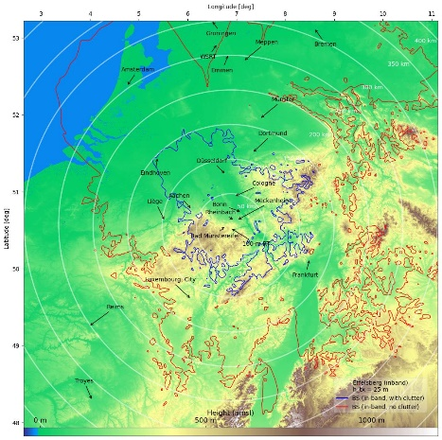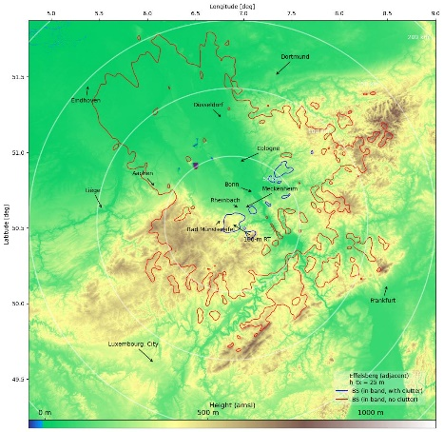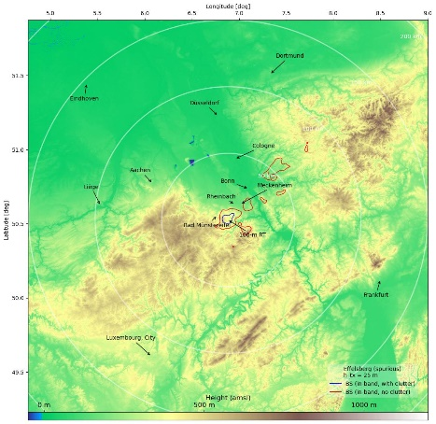
Figure A4-14
Single-interferer coordination distances for the Lovell telescope/Jodrell Bank Observatory (UK)
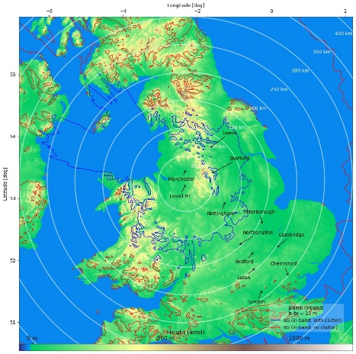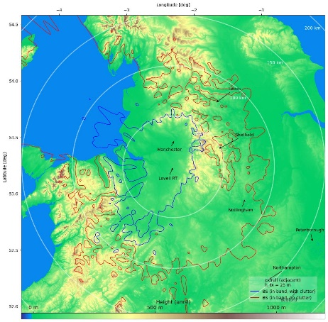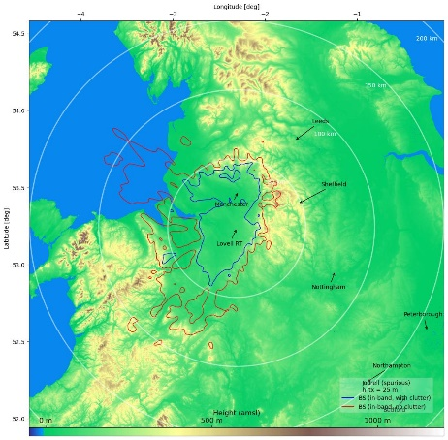
Figure A4-15
Single-interferer coordination distances for the Sardinia Radio Telescope (Italy)
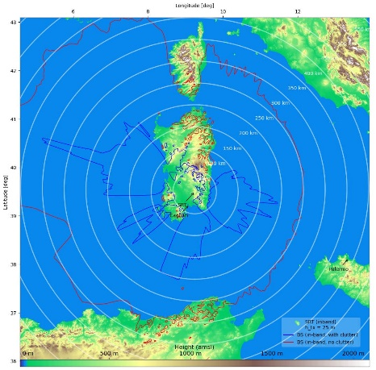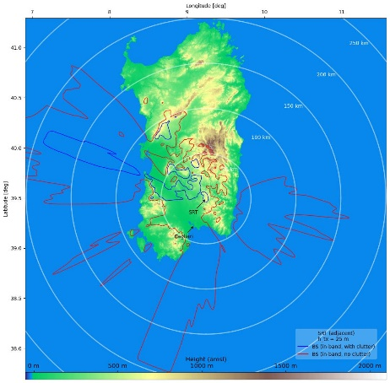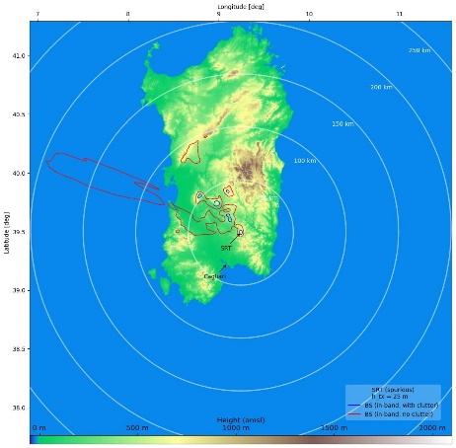
Figure A4-16
Single-interferer coordination distances for the Yebes 40-m radio telescope (Spain)
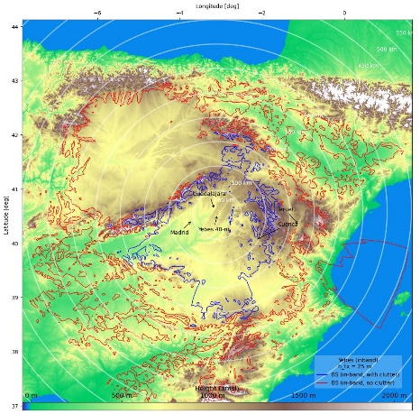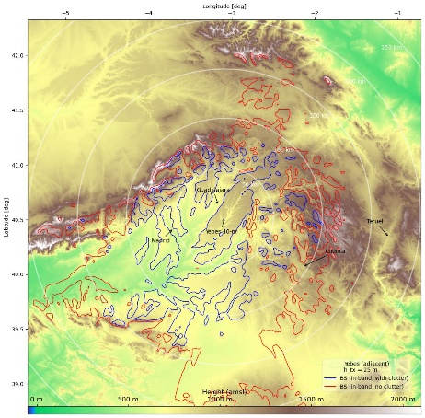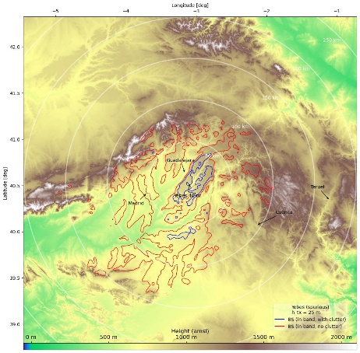

A4.4.1.3 Summary
The results derived in Section A4.4.1.2 indicate that in the single-interferer worst-case scenario coordination distances of up to 200-250 km could be required in the sharing scenario, or even much more if the IMT base stations are not subject to full clutter losses (27 dB). For the adjacent and spurious domain cases, the coordination distances are still 50-100 km (with clutter). An exception is the 100-m telescope at Effelsberg in Germany, for which natural terrain shielding is somewhat more efficient at these frequencies. When clutter loss is applied, coordination distances are less than 10 km in the spurious domain case.
Given the relatively large coordination zone size – even for the spurious domain – additional mitigation measures may be considered. Some possible actions are listed in Section 5.
The results demonstrate very well, how fundamental the assumed clutter losses are for the sharing and compatibility between IMT and RAS. If combined with additional mitigation measures, co-existence is well possible, but IMT base stations must not be put at elevated heights, i.e., above the local roof-tops. Otherwise, IMT devices could cause interference to the RAS over significant distances. The restriction that base-station beams should never be pointed to above the horizon has little effect and cannot be considered as an important mitigation measure in many practical cases.

A4.5 Possible mitigation measures
The calculation results, especially for the aggregation scenario in Section A4.3.2, indicate that coordination between IMT base stations at 6.6 GHz and RAS sites will be necessary, if protection of the radio astronomy operations in this band is desired. Several mitigation and coordination techniques exist, which will be described in the following.

A4.5.1 Choice of RAS site and suppression of telescope side lobes
Recommendation ITU-R RA.611-4 specifies “that radio astronomy observatories should continue to be placed in locations that have good natural protection from interference that may be detrimental to the RAS” and “that all practicable efforts should be made to minimize the side-lobe gains of radio astronomy antennas”. In fact, most modern RAS stations are operated in very remote places to minimize the impact of anthropogenic sources on astronomical observations. Natural terrain shielding, e.g. when the RAS site is surrounded by hills or mountains, is also a very effective tool to reduce the received power from terrestrial sources.
Radio astronomy telescope side lobes can to some extent be controlled with tapering the main dish. Here a compromise has to be found between aperture efficiency of the antenna and the reduction of near side-lobes, which would suppress some of the off-axis interference contributions.

A4.5.2 IMT site planning
The general methodology for determining the need for mitigation methods described in the main body of this report is predicated on standardized deployment models. More site-specific deployments models, accounting for specific coverage needs for a given area, may provide both more realistic compatibility data and a means to vary parameters to resolve potential interference issues.
As explained above, the terrain and clutter around the RAS station play an important role. However, the path propagation equally depends on the situation at the transmitter, as the local terrain also provides diffraction (actually, any terrain features on the full propagation path are relevant). Unless the BSs are installed at highly elevated antenna masts, clutter loss from objects around the transmitter applies; these could include houses, trees, etc. Placing IMT equipment such that local clutter is effective in the direction of the RAS station can make a significant difference. A transmitter attached to a wall on the opposite side of a house as seen from the RAS station will contribute much less to the received power than a transmitter on the facing side.
Site-specific characteristics, such as placing BSs so that main beam illumination covers a service area while pointing away from a RAS site, transmission power levels, lower deployment densities, and taking advantage of geographic characteristics may serve as factors which individually or in combination improve compatibility.
In some cases, ensuring compatibility may require minimum coordination distances between the IMT deployment and RAS systems, regardless of other measures employed.
Terrain and clutter at any point in the propagation path from transmitter to receiver are relevant, and impact received signal through diffraction. Thus, clutter loss near transmitter, receiver, and at any point in between is relevant. IMT site planning such that clutter loss is increased toward nearby RAS sites may improve compatibility.
To demonstrate the effectiveness of this approach, the aggregation simulations have been repeated for the case that all base stations are subject to the full clutter loss (in Section 3.2 it was assumed that a fraction of the BS would be installed significantly above the roof-tops and thus not be affected by clutter). As Figure A4-17 reveals, the received aggregated power levels are then at least 20 dB lower, which reduces the required minimum coordination distances accordingly.
Figure A4-17
As Figure 10, but assuming that clutter attenuation applies to all base stations (BS installed below rooftops)
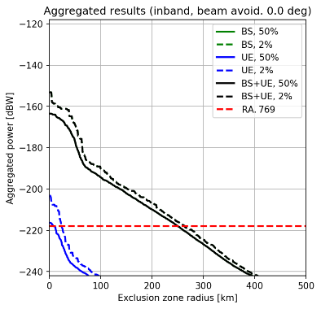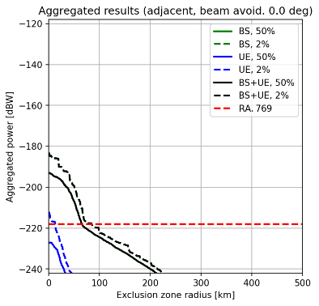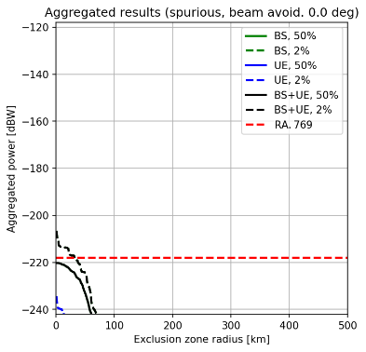
Once the baseline analysis of compatibility is conducted and a determination made that potential coordination issues may arise, a more computationally intensive further analysis accounting for more detailed modelling of a given site, including terrain, foliage, and other geographic factors, may be conducted. It may be desirable to conduct such an analysis in conjunction with the other factors detailed in this section.

A4.5.3 AAS, beamforming, and antenna orientation
Modern 5G systems often utilize active antenna systems (AAS), i.e., arrays of many antenna elements. AAS can form beams electronically, which can be steered in real time towards the required position (usually the UE). This would, in principle, also allow to program the BSs in a way such that the location of an RAS station is avoided by the BS beam and its side-lobes. In addition, the array antenna could be mounted in a way such that it has large angular separation between its antenna normal and the location of the RAS station.
To test, how efficient beam steering could be for the reduction of interference into the RAS band, the aggregation calculations presented in Section A4.3.2 have been repeated, but for various avoidance angles around the direction to the radio astronomy site. As the effect will qualitatively be the same for in- and out-of-band scenarios, only the in-band case was computed. In the simulations, the propagation path from the base stations to the RAS site is inferred. IMT base stations beams pointing within $x$ degrees around this propagation path direction were switched off, with various values for $x$ tested (1, 5, 10, 20, 30 degs). It is noted that this is an oversimplification, as in reality the beam would be pointed elsewhere instead of switched off. Owing to the relatively large beam-width and the high side-lobe gain of the AAS pattern, the reduction of the interference power is visible but not extremely effective, as shown in Figure A4-18. Even if a fairly large area of 30 deg around the propagation path direction is avoided, the net effect does not exceed 10 dB.
Figure A4-18
Results for the aggregated scenario in the 6 425-7 025 MHz band
(Effect of angular avoidance around direction to RAS site)
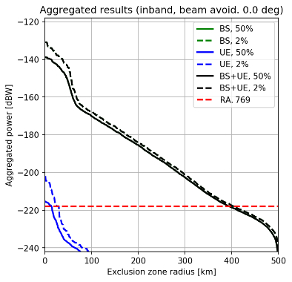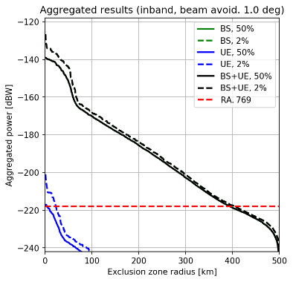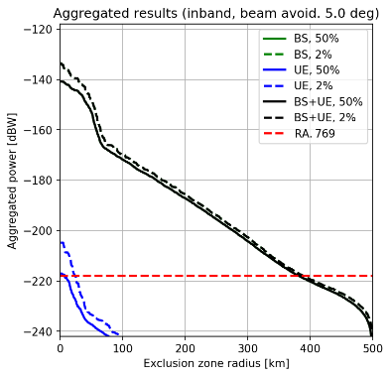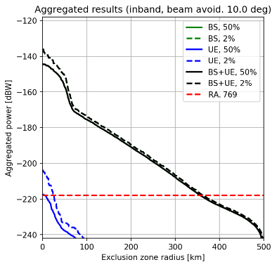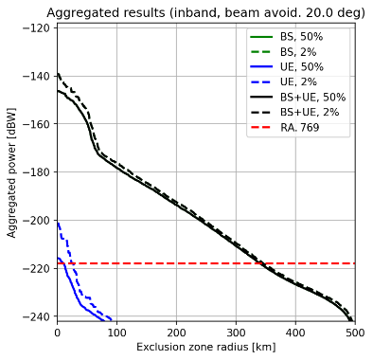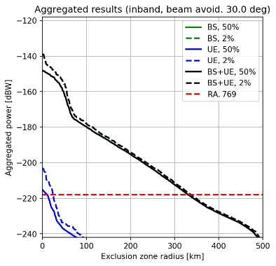

A4.5.4 Network management
As the results in Section A4.3.2 indicate that the major contribution to the received power at the RAS receiver stems from base stations, another mitigation method would be to use the RAS band only for uplinks. In this case, only a relatively small area around the telescope sites would have to be coordinated to avoid user terminals in the immediate vicinity.

It is noted that Rec. ITU-R M.2101-0 uses azimuth, $φ$, and zenith angle (wrongly referred to as elevation), $θ=90°-ϑ$, instead of elevation angle, $ϑ$. In contrast, the tilt angle, $θ_{i,tilt}$, is not used as a zenith angle, but as elevation with opposite sign.
In Rec. ITU-R P.452-17, the azimuthal direction to the receiver is given by $α_{tr}$ (their equation 67), while the transmit elevation angle is denoted as $θ_{t}$ (their equation 154). However, $α_{tr}$ is defined with respect to North, while the $\left(u, v, h\right)$ system used in this Report is with respect to East, i.e., $φ_{pp}=90°-α_{tr}$.

